

**Module Code & Module Title**

**CC6001NI - Advanced Database System Development**

**Assessment Weightage & Type**

**40% Individual Coursework**

**Year and Semester**

**2020-21 Autumn**

**Student Name: Suyogya Luitel**

**Group: C3**

**London Met ID: 19031784**

**College ID: NP01CP4A190035**

**Assignment Due Date: 09th March 2022**

**Assignment Submission Date: 09th March 2022**

I confirm that I understand my coursework needs to be submitted online via Google Classroom under the relevant module page before the deadline for my assignment to be accepted and marked. I am fully aware that late submissions will be treated as non-submission and a mark of zero will be awarded.

# Introduction

This is a report of the coursework involving analysis, design, and implementation of a web-based database application in accordance with the given business case study with the help of tools such as Oracle SQL Developer Data Modeler, Oracle SQL Developer and ASP.NET. According to the presented business scenario, the database should contain information regarding college departments; students, including fee status and attendance; assignments, and their results.

Initially the database is normalized based on given example data and integrated along with assumptions to better fit the given business scenario. The final entities and relations obtained from integration are visualized with Oracle Developer Data Modeler and a DDL script is generated. The generated DDL is then used to generate a database through Oracle SQL, which is then populated with sample data. Webforms are then created to perform CRUD operations on some tables and selective filtration operations on joined tables. Testing is then performed

# Textual Analysis

From the given case study, I derived the following relations between entities:

## Teacher-Module

A teacher is allowed to teach multiple modules.

A module can be taught by multiple teachers.

Hence, a many-to-many relation seems to be established.

Figure : Relation between Module and Teacher

## Student-Module

A student can study multiple modules.

A module can be studied by multiple students.

Hence a many-to-many relation seems to be established.

Figure : Relation between Module and Student

## Student-Assignment

A student can partake in multiple assignments.

An assignment is submitted by multiple students.

Hence, a many-to-many relation is established.

Figure : Relation between Student and Assignment

## Department-Fees-Assignment-Result

A department manages multiple student fees.

A department manages multiple assignments.

A department manages multiple results.

Student fee is managed by a single department.

Assignment is managed by a single department.

Result is managed by a single department.

Hence, department establishes a one-to-many relation with fees, assignments, and results.

Figure : Relation between Department with Fees, Assignments and Results

# ERD From Case Study

Based on the relations derived in the textual analysis of the given case study and some general assumptions, the following ERD is generated.

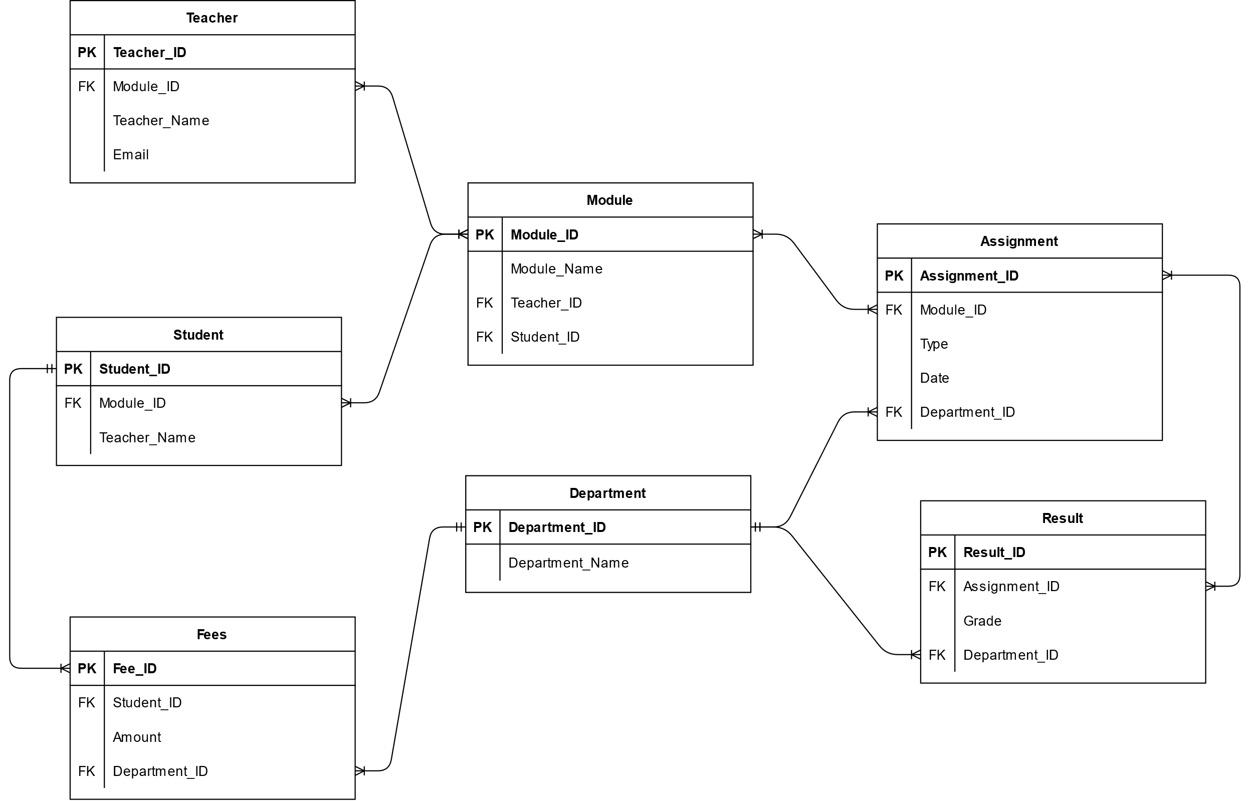

Figure : Initial ERD from Case Study

Assumptions:

* A student pays multiple fees throughout their stay in the college, and a fee belongs to only one student.
* Multiple results are published for the same assignment and a result relates to multiple assignments.
* A module may be included in multiple assignments and an assignment type may be implemented for multiple modules.

# Normalization

## Figure 1: Example of Teacher allocation list

|  |  |  |  |  |  |  |
| --- | --- | --- | --- | --- | --- | --- |
| S.N. | Teacher Name | Address | Email | Module  Code | Module Name | Credit Hours |
| 1 | Saul Goodman | 595 Green Lake Road  Black Lake  9115 Lake Street Harrietsfield | Saulthegoodman@ abc.edu.np | CC12 | Data Structure and Algorithm | 30 |
| 2 | Walter White | 696 Madison St. Pierrefonds | [whitywalker@abc.e](mailto:whitywalker@abc.e) du.np | CC12 | Data Structure and Algorithm | 30 |
| 3 | Santana Lopez | 6 Valley View Street Griffintown | Santanalopez@abc. edu.np | CC49 | Engineering Thermodynamic | 60 |
| 4 | Rust Cohle | 89 Coffee Dr. Plaster Rock | [rustycohle@abc.ed](mailto:rustycohle@abc.ed) u.np | SG101 | Software engineer | 30 |
|  |  |  |  | TG405 | Data Analysis | 50 |

Table : Example of Teacher allocation list

Normalization of teacher allocation:

### UNF

Identifying the repeating groups among the given figure fields, we get the following UNF:

Teacher(Teacher_ID, Teacher_Name, {Street_No., Street_Name, State_Name}, Email, {Module_Code, Module_Name, Credit_Hours,})

### 1NF

Separating the repeating groups identified in the UNF above and assigning composite keys, we get the following entities:

Teacher-1 (Teacher_ID, Teacher_Name, Email)

Address-1(Address_ID, Teacher_ID*, Street_No., Street_Name, State_Name)

Module-1(Module_Code, Teacher_ID*, Module_Name, Credit_Hours)

### 2NF

After the repeating groups were separated into different entities and assigned new composite keys, they needed to be checked for partial dependencies.

For Teacher-1:

* No composite keys were present and hence there were no partial dependencies.

Teacher_ID → Teacher_Name, Email

Teacher-2 (Teacher_ID, Teacher_Name, Email)

For Address-1:

* Address_ID key determines Street_No., Street_Name, State_Name
* Address_ID, Teacher_ID* composite key determines nothing
* Teacher_ID* foreign key determines nothing

Address_ID → (Street_No., Street_Name, State_Name)

Address_ID, Teacher_ID* → ()

Teacher_ID → ()

The partial dependencies are separated into new entities as:

Address-2 (Address_ID*, Street_No., Street_Name, State_Name)

Address-Teacher-2 (Address_ID, Teacher_ID*)

For Module-1:

* Module_Code key determines Module_Name, Credit_Hours
* Module_Code, Teacher_ID* composite key determines nothing

Module_Code → (Module_Name, Credit_Hours)

Module_Code, Teacher_ID* → ()

Module -2 (Module_Code, Module_Name, Credit_Hours)

Module-Teacher -2 (Module_Code, Teacher_ID*)

Hence, the results of 2NF are the following entities:

Teacher-2 (Teacher_ID, Teacher_Name, Email)

Address-2 (Address_ID→ Street_No., Street_Name, State_Name)

Address-Teacher-2 (Address_ID, Teacher_ID*)

Module -2 (Module_Code, Module_Name, Credit_Hours)

Module-Teacher -2 (Module_Code, Teacher_ID*)

### 3NF

After checking and removing any partial dependencies, transitive dependencies are required to be checked and removed.

For Teacher-2:

* Teacher_ID determines Teacher_Name and Email
* Teacher_Name determines nothing
* Email determines nothing

There are no transitive dependencies.

Teacher-3 (Teacher_ID, Teacher_Name, Email)

For Address-2:

* Address_ID determines Street_No., Street_Name, State_Name
* Address determines nothing

There are no transitive dependencies.

Address-3 (Address_ID, Street_No., Street_Name, State_Name)

For Address-Teacher 2:

There are no transitive dependencies, the entity contains only a composite primary key.

Address-Teacher-3 (Address_ID, Teacher_ID*)

For Module-Teacher 2:

There are no transitive dependencies, the entity contains only a composite primary key.

Module-Teacher-3 (Module_ID, Teacher_ID*)

For Module-2:

* Module_Code determines Module_Name, Credit_Hours
* Module_Name determines nothing
* Credit_Hours determines nothing

Module_Code → (Module_Name, Credit_Hours)

The transitive dependencies are separated into entities as follows:

Module-3 → (Module_Code, Module_Name, Credit_Hours)

Hence, the results of 3NF are the following entities:

Teacher-3 (Teacher_ID, Teacher_Name, Email)

Address-3 (Address_ID, Address)

Address-Teacher-3 (Address_ID, Teacher_ID*)

Module-3 (Module_Code, Module_Name, Credit_Hours)

Module-Teacher-3 (Module_ID, Teacher_ID*)

### Final entities from figure 1

After normalizing figure 1 up to third normal form, the following entities are obtained:

Teacher (Teacher_ID, Teacher_Name, Email)

Address (Address_ID, Street_No., Street_Name, State_Name)

Address-Teacher (Address_ID, Teacher_ID*)

Module (Module_Code, Module_Name, Credit_Hours)

Module-Teacher (Module_ID, Teacher_ID*)

## Fig 2: Example of Assignment and Examination Results

Student ID: 149893

Student Name: Mr. William Ishee

Student Address: 2508 Shinn Street New York

|  |  |  |  |  |
| --- | --- | --- | --- | --- |
| Module  Code | Module Name | Assignment Type | Grade | Status |
| CC12 | Data Structure and Algorithm | Coursework | A | Pass |
| CC49 | Engineering Thermodynamic | Coursework | B | Pass |
| CC49 | Engineering Thermodynamic | Written Exam | F | Fail |
| SG101 | Software engineer | Individual  Assignment | B+ | Pass |
| SG101 | Software engineer | Group Assignment | B | Pass |
| SG101 | Software engineer | Unseen Examination | A | Pass |

**Assumptions**:

* A student cannot have multiple addresses.

### UNF

Adding the above-mentioned fields to the given Figure 2 fields, and identifying the repeating groups among them, we get the following UNF:

Student (Student_ID, Sudent_Name, Street_No., Street_Name, State_Name, {Module_Code, Module_Name {Assignment_Type, Grade, Status}})

### 1NF

Separating the repeating groups identified in the UNF above and assigning composite keys, we get the following entities:

Student-1(Student_ID, Student_Name, Street_No., Street_Name, State_Name)

Module-1 (Module_Code, Student_ID*, Module_Name)

Assignment-1(Assignment_ID, Student_ID*, Module_Code*, Assignment_Type, Grade, Status)

### 2NF

After the repeating groups were separated into different entities and assigned new composite keys, they needed to be checked for partial dependencies.

For Student-1:

* No composite keys were present and hence there were no partial dependencies.

Student_ID → (Student_Name, Street_No., Street_Name, State_Name)

Student-2 (Student_ID, Student_Name, Street_No., Street_Name, State_Name)

For Module-1:

* Module_Code key determines Module_Name
* Module_Code, Student_ID* composite key determines nothing
* Student _ID* foreign key determines nothing

Student_ID, Module_Code → ()

Student_ID → ()

Module_Code → (Module_Name)

Module-Student-2 (Student_ID*, Module_Code*)

Module-2(Module_Code, Module_Name)

For Assignment-1:

* Assignment_ID key determines Assigment_Type
* Assignment_ID, Student_ID*, Module_Code* composite key determines Grade, Status
* Student _ID* foreign key determines nothing
* Module _Code* foreign key determines nothing

Assignment_ID → (Assignment_Type)

Assignment_ID, Student_ID, Module_Code → (Grade, Status)

Student_ID → ()

Module_Code → ()

The partial dependencies are separated into new entities as:

Assignment-2 (Assignment_ID, Assignment_Type)

Student-Assignment-2(Assignment_ID*, Student_ID*, Module_Code*, Grade, Status)

Hence, the results of 2NF are the following entities:

Student-2 (Student_ID, Student_Name, Street_No., Street_Name, State_Name)

Module-Student-2 (Student_ID*, Module_Code*)

Module-2(Module_Code, Module_Name)

Assignment-2 (Assignment_ID, Assignment_Type)

Student-Assignment-2(Assignment_ID*, Student_ID*, Module_Code*, Grade, Status)

### 3NF

After checking and removing any partial dependencies, transitive dependencies are required to be checked and removed.

For Student-2 :

* Student_ID determines Student_Name, Street_No., Street_Name, State_Name Student_Name determines nothing
* Student_Address determines nothing

Student_ID → (Student_Name, Street_No., Street_Name, State_Name)

There are no transitive dependencies.

Student-3 (Student_ID, Student_Name, Street_No., Street_Name, State_Name)

For Module-Student-2:

There are no transitive dependencies, the entity contains only a composite primary key.

Module-Student-3 (Student_ID*, Module_Code*)

For Module-2:

* Module_Code determines Module_Name
* Module_Name determines nothing

There are no transitive dependencies.

Module-3(Module_Code, Module_Name)

For Assignment-2:

* Assignment_ID determines Assigment_Type
* Assignment_Type determines nothing
* Module_Name determines nothing

There are no transitive dependencies.

Assignment-3 (Assignment_ID, Assignment_Type)

For Student-Assignment-2:

* Assignment_ID, Student_ID, Module_Code composite key determines Grade
* Grade determines Status
* Status determines nothing

Assignment_ID*, Student_ID*, Module_Code* → Grade

Grade → Status

The transitive dependencies are separated as:

Student-Assignment-3 (Assignment_ID*, Student_ID*, Module_Code*, Grade_ID*)

Grade-3 (Grade_ID, Grade, Status)

Hence, the results of 3NF are the following entities :

Student-3 (Student_ID, Student_Name, Street_No., Street_Name, State_Name)

Module-Student-3 (Student_ID*, Module_Code*)

Module-3(Module_Code, Module_Name)

Assignment-3 (Assignment_ID, Assignment_Type)

Student-Assignment-3 (Assignment_ID*, Student_ID*, Module_Code*, Grade_ID*)

Grade-3 (Grade_ID, Grade, Status)

### Final entities from figure 2

After normalizing figure 2 up to third normal form, the following entities are obtained:

Student (Student_ID, Student_Name, Street_No., Street_Name, State_Name)

Module-Student (Student_ID*, Module_Code*)

Module(Module_Code, Module_Name)

Assignment (Assignment_ID, Assignment_Type)

Student-Assignment (Assignment_ID*, Student_ID*, Module_Code*, Grade_ID*)

Grade (Grade_ID, Grade, Status)

# Integration and Assumptions

Assumptions:

* A teacher may have multiple addresses, but a student can only have one address recorded.
* Grade is evaluated in a single alphabet optionally followed by a sign (Ex: A, A+).
* College has additional departments for managing examinations, assessments, results, as well as fees.
* Attendance of students is managed by a different system and recorded for each semester in percentage value in this database at the end of each semester right before examinations are conducted.
* Each semester has a fee associated with it which may or may not be equal for all semesters.
* Semester fees of the students are common regardless of the modules they study. This implies that students A and B studying module sets C and D have the same semester fees if they both are in semester E.
* Each semester, students are required to pay the allocated semester fees in a single installment.
* When a student pays semester fees, their fee status is updated to paid.
* To store the fees paid amount, the fee amount is redundantly added to the student_fees table so it always remains the same even if the semester fees change over time.
* Assignments and their results, attendance, and fees are managed by departments
* A student can study any three module they want.
* A teacher can teach one or multiple modules.
* Different semesters may have different fees.
* Student assignments for each module are recorded only after their grades have been evaluated.
* A student, after graduation, may become a teacher. Hence, a reference for student_id is added to the teacher table in case a student does become a teacher after graduation.

While the given example tables are very informative, they do not contain information regarding college departments. They also do not contain information regarding semester, semester fees, attendance, and fee status. Thus, the entities "Department", and "Semester", "Student_Fees" and "Student_Attendance" are added to the result of normalizing figures one and two with appropriate relations to existing entities.

Teacher (Teacher_ID, Teacher_Name, Email, Student_ID*)

Address (Address_ID, Street_No., Street_Name, State_Name)

Address-Teacher (Address_ID, Teacher_ID*)

Module (Module_Code, Module_Name, Credit_Hours)

Module-Teacher (Module_ID*, Teacher_ID*)

Student (Student_ID, Student_Name, Street_No., Street_Name, State_Name)

Module-Student (Student_ID*, Module_Code*)

Department (Department_ID, Department_Name)

Assignment (Assignment_ID, Assignment_Type, Department_ID*)

Student-Assignment (Assignment_ID*, Student_ID*, Module_Code*, Grade_ID*)

Grade (Grade_ID, Grade, Status)

Semester (Semester_ID, Semester, Semester_Fees)

Student_Fees (Semester_ID*, Student_ID*, Fee_Status, Department_ID*, Fee_Amount)

Student_Attendance (Semester_ID*, Student_ID*, Attendance_Percentage)

# Final ERD

After normalization and integration of the given two example figures, the obtained entities form the following ERD:

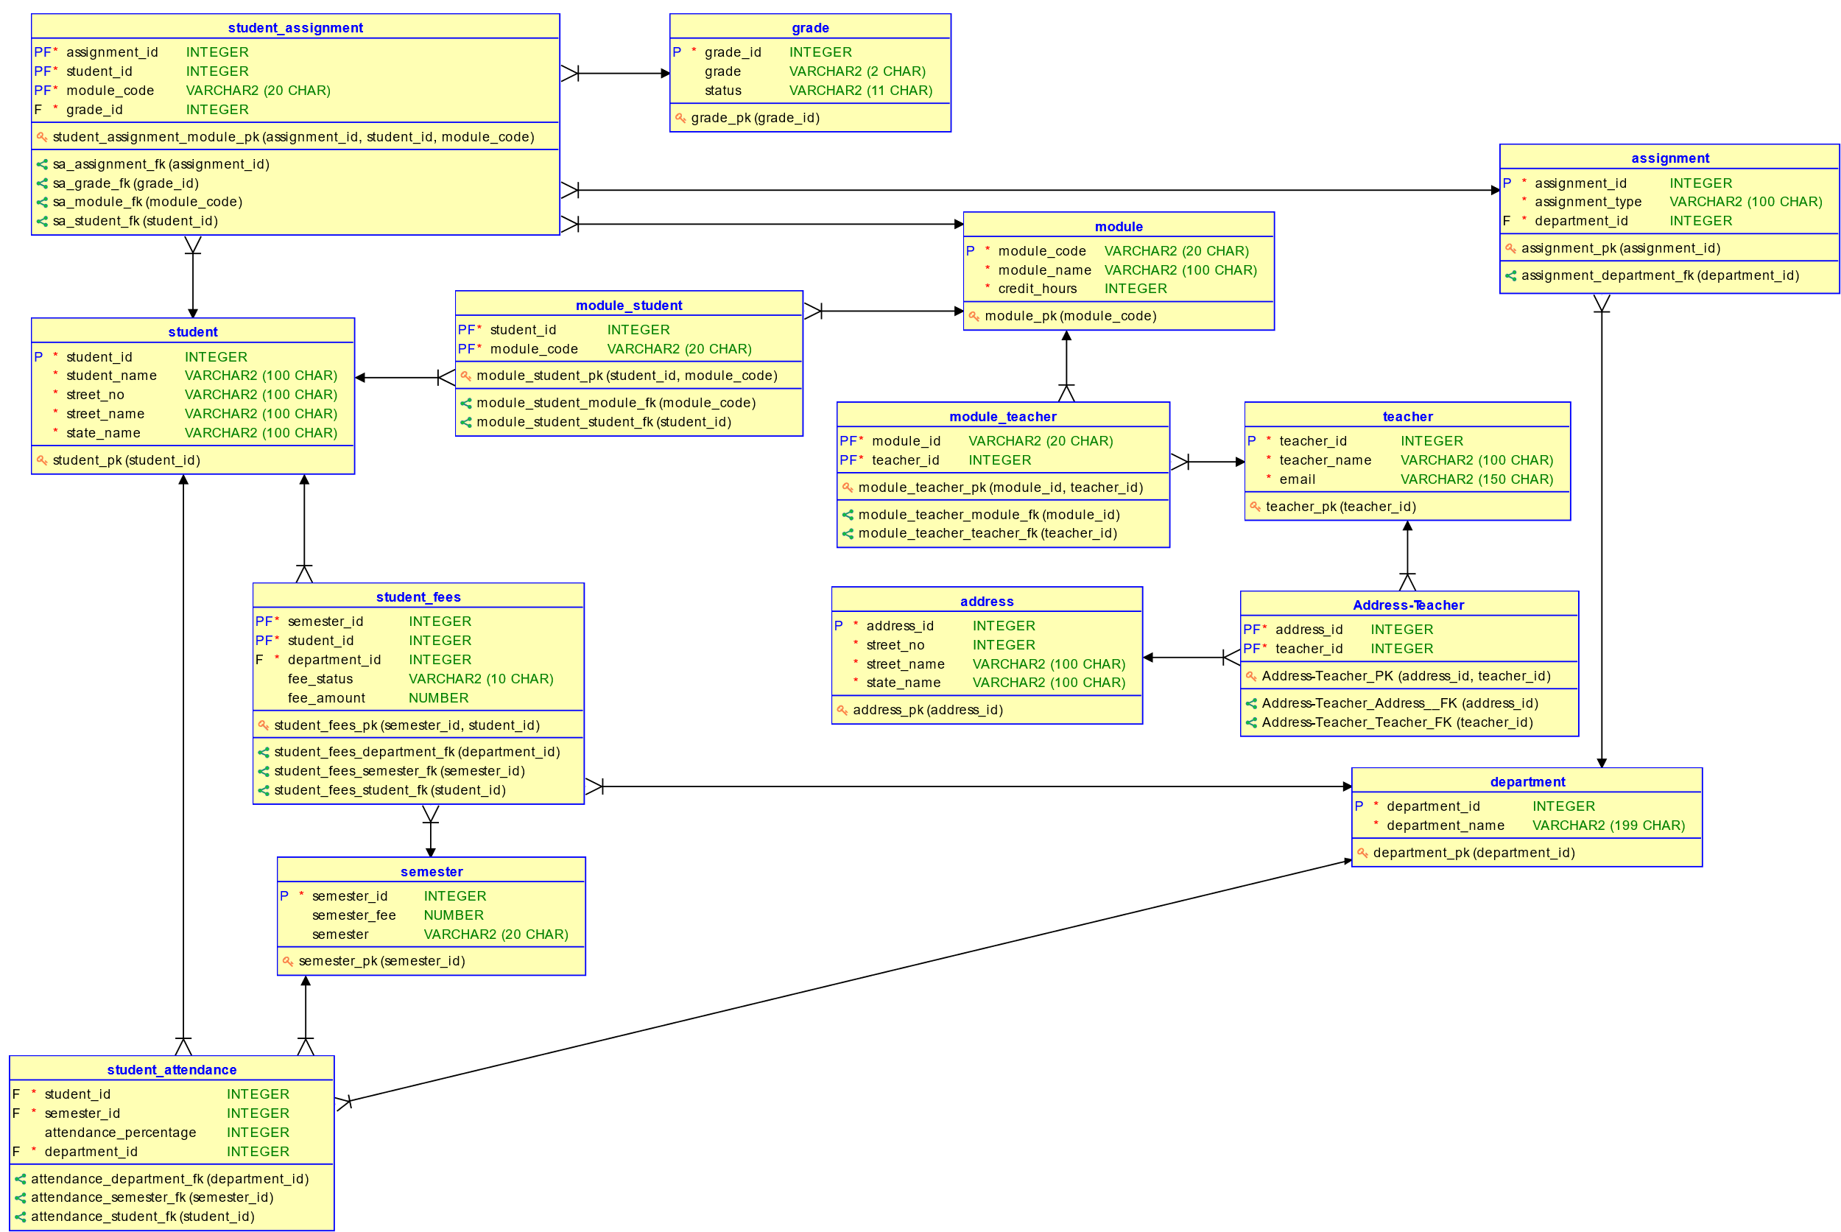

Figure : Final ERD After Integration

# Data Dictionary

## Table: Teacher

|  |  |  |  |  |  |  |  |
| --- | --- | --- | --- | --- | --- | --- | --- |
| Column Name | Data Type | Size | Constraint | Reference Table | Reference Column | Description | Sample Data |
| Teacher_ID | INTEGER | 38 | Primary Key |  |  | Uniquely identifies each teacher | 9 |
| Teacher_Name | VARCHAR | 100 | NOT NULL |  |  | Stores the name of the teacher | 4251 |
| Email | VARCHAR | 100 | NOT NULL, UNIQUE |  |  | Stores the active email address of the teacher | Ethan_  Cunningham  2529@brety  .org |
| Student_ID | INTEGER | 38 |  |  |  | Stores student id of the person if they were a graduated student | 6 |

Table : Teacher Table Dictionary

## Table: Student

|  |  |  |  |  |  |  |  |
| --- | --- | --- | --- | --- | --- | --- | --- |
| Column Name | Data Type | Size | Constraint | Reference Table | Reference Column | Description | Sample Data |
| Student_ID | INTEGER | 38 | Primary Key |  |  | Uniquely identifies each student | 5 |
| Student_Name | VARCHAR | 100 | NOT NULL |  |  | Stores the name of the student | Ethan Shrestha |
| Street_No | INTEGER | 38 | NOT NULL |  |  | Stores street number of an address | 4251 |
| Street_Name | VARCHAR | 100 | NOT NULL |  |  | Stores street name of an address | Sheffield Walk |
| State_Name | VARCHAR | 100 | NOT NULL |  |  | Stores state name of an address | Hawaii |

Table : Student Table Dictionary

## Table: Address

|  |  |  |  |  |  |  |  |
| --- | --- | --- | --- | --- | --- | --- | --- |
| Column Name | Data Type | Size | Constraint | Reference Table | Reference Column | Description | Sample Data |
| Address_ID | INTEGER | 38 | Primary Key |  |  | Uniquely identifies each address | 3 |
| Street_No | INTEGER | 38 | NOT NULL |  |  | Stores street number of an address | 4251 |
| Street_Name | VARCHAR | 100 | NOT NULL |  |  | Stores street name of an address | Sheffield Walk |
| State_Name | VARCHAR | 100 | NOT NULL |  |  | Stores state name of an address | Hawaii |

Table : Address Table Dictionary

## Table: Department

|  |  |  |  |  |  |  |  |
| --- | --- | --- | --- | --- | --- | --- | --- |
| Column Name | Data Type | Size | Constraint | Reference Table | Reference Column | Description | Sample Data |
| Department_ID | INTEGER | 38 | Primary Key |  |  | Uniquely identifies each department | 9 |
| Department_Name | VARCHAR | 100 | NOT NULL, UNIQUE |  |  | Stores the name of the department | RTE |

Table : Department Table Dictionary

## Table: Assignment

|  |  |  |  |  |  |  |  |
| --- | --- | --- | --- | --- | --- | --- | --- |
| Column Name | Data Type | Size | Constraint | Reference Table | Reference Column | Description | Sample Data |
| Assignment_ID | INTEGER | 38 | Primary Key |  |  | Uniquely identifies each assignment | 2 |
| Assignment_Type | VARCHAR | 100 | NOT NULL, UNIQUE |  |  | Stores the type of current assignment | 4251 |
| Department_ID | VARCHAR | 100 | NOT NULL | Department | Department  _ID | Stores the department ID that manages assignments | Sheffield Walk |

Table : Assignment Table Dictionary

## Table: Grade

|  |  |  |  |  |  |  |  |
| --- | --- | --- | --- | --- | --- | --- | --- |
| Column Name | Data Type | Size | Constraint | Reference Table | Reference Column | Description | Sample Data |
| Grade_ID | INTEGER | 38 | Primary Key |  |  | Uniquely identifies each grade as a number | 2 |
| Grade | VARCHAR | 100 | NOT NULL, UNIQUE |  |  | Stores the grade | D+ |
| Status | VARCHAR | 100 | NOT NULL |  |  | Stores the pass or fail status of the grade | Pass |

Table : Grade Table Dictionary

## Table: Module

|  |  |  |  |  |  |  |  |
| --- | --- | --- | --- | --- | --- | --- | --- |
| Column Name | Data Type | Size | Constraint | Reference Table | Reference Column | Description | Sample Data |
| Module_Code | VARCHAR | 20 | Primary Key |  |  | Uniquely identifies each assignment | CC12 |
| Module_Name | VARCHAR | 100 | NOT NULL, UNIQUE |  |  | Stores the name of the module | Data Structure and Algorithm |
| Credit_Hours | INTEGER | 38 | NOT NULL |  |  | Stores the credit hours of the module | 30 |

Table : Module Table Dictionary

## Table: Module_Student

|  |  |  |  |  |  |  |  |
| --- | --- | --- | --- | --- | --- | --- | --- |
| Column Name | Data Type | Size | Constraint | Reference Table | Reference Column | Description | Sample Data |
| Student_ID | VARCHAR | 100 | FOREIGN KEY, PRIMARY KEY (composite primary key) | Student | Student_ID | Stores the student id of the student associated with a module | 6 |
| Module_Code | VARCHAR | 20 | FOREIGN KEY, PRIMARY KEY (composite primary key) | Module | Module_Code | Stores the module code of a module associated with the student | CC12 |

Table : Module_Student Table Dictionary

## Table: Module_Teacher

|  |  |  |  |  |  |  |  |
| --- | --- | --- | --- | --- | --- | --- | --- |
| Column Name | Data Type | Size | Constraint | Reference Table | Reference Column | Description | Sample Data |
| Teacher_ID | VARCHAR | 100 | FOREIGN KEY, PRIMARY KEY (composite primary key) | Teacher | Teacher_ID | Stores the teacher id of the teacher associated with a module | 9 |
| Module_ID | VARCHAR | 20 | FOREIGN KEY, PRIMARY KEY (composite primary key) | Module | Module_Code | Stores the module code of a module associated with the teacher | CC12 |

Table : Module_Teacher Table Dictionary

## Table: Semester

|  |  |  |  |  |  |  |  |
| --- | --- | --- | --- | --- | --- | --- | --- |
| Column Name | Data Type | Size | Constraint | Reference Table | Reference Column | Description | Sample Data |
| Semester_ID | INTEGER | 38 | Primary Key |  |  | Uniquely identifies each semester | 6 |
| Semester | INTEGER | 38 | NOT NULL, UNIQUE |  |  | Stores the semester number | 9 |
| Semester_Fees | INTEGER | 38 | NOT NULL |  |  | Stores the fee for the semester | 650 |

Table : Semester Table Dictionary

## Table: Student_Assignment

|  |  |  |  |  |  |  |  |
| --- | --- | --- | --- | --- | --- | --- | --- |
| Column Name | Data Type | Size | Constraint | Reference Table | Reference Column | Description | Sample Data |
| Assignment_ID | INTEGER | 38 | FOREIGN KEY, PRIMARY KEY (composite primary key) | Assignment | Assignment_ID | Stores the assignment id of the assignment | 6 |
| Student_ID | INTEGER | 38 | FOREIGN KEY, PRIMARY KEY (composite primary key) | Student | Student_ID | Stores the student id of the student associated with the assignment | 9 |
| Module_Code | VARCHAR | 20 | FOREIGN KEY, PRIMARY KEY (composite primary key) | Module | Module_Code | Stores the module id of the module of which thew assignment is | CC12 |
| Grade_ID | INTEGER | 38 | FOREIGN KEY | Grade | Grade_ID | Stores the grade id of the grade obtained by the student | 3 |

Table : Student_Assignment Table Dictionary

## Table: Student_Attendance

|  |  |  |  |  |  |  |  |
| --- | --- | --- | --- | --- | --- | --- | --- |
| Column Name | Data Type | Size | Constraint | Reference Table | Reference Column | Description | Sample Data |
| Student_ID | INTEGER | 38 | FOREIGN KEY, PRIMARY KEY (composite primary key) | Student | Student_ID | Stores the student id of the student whose attendance is being recorded | 6 |
| Semester_ID | INTEGER | 38 | FOREIGN KEY, PRIMARY KEY (composite primary key) | Semester | Semester_ID | Stores the semester id of the semester in which the attendance was recorded | 3 |
| Department_ID | INTEGER | 38 | FOREIGN KEY, NOT NULL | Department | Department_ID | Stores the department id of the department responsible for managing attendance | 1 |

Table : Student_Attendance Table Dictionary

## Table: Student_Fees

|  |  |  |  |  |  |  |  |
| --- | --- | --- | --- | --- | --- | --- | --- |
| Column Name | Data Type | Size | Constraint | Reference Table | Reference Column | Description | Sample Data |
| Student_ID | INTEGER | 38 | FOREIGN KEY, PRIMARY KEY (composite primary key) | Student | Student_ID | Stores the student id of the student whose fee detail is being recorded | 6 |
| Semester_ID | INTEGER | 38 | FOREIGN KEY, PRIMARY KEY (composite primary key) | Semester | Semester_ID | Stores the semester id of the semester for which the fee detail was recorded | 3 |
| Department_ID | INTEGER | 38 | FOREIGN KEY, NOT NULL | Department | Department_ID | Stores the department id of the department responsible for managing fees | 2 |
| Fee_Amount | NUMBER | (30,8) |  |  |  | Stores the amount of fee paid by the student | 700 |
| Fee_Status | VARCHAR | 10 |  |  |  | Stores the status of fees determining if the fee has been paid or not | Due |
| Payment_Date | DATE |  |  |  |  | Stores the date of payment of | TO_DATE( '09, 01, 2017', 'MM, DD, YYYY' ) |

Table : Student_Attendance Table Dictionary

## Table: Address_Teacher

|  |  |  |  |  |  |  |  |
| --- | --- | --- | --- | --- | --- | --- | --- |
| Column Name | Data Type | Size | Constraint | Reference Table | Reference Column | Description | Sample Data |
| Teacher_ID | INTEGER | 38 | FOREIGN KEY, PRIMARY KEY (composite primary key) | Teacher | Teacher_ID | Stores the teacher id of the teacher associated with an address | 6 |
| Address_ID | INTEGER | 38 | FOREIGN KEY, PRIMARY KEY (composite primary key) | Address | Address_ID | Stores the address id of the address that is associated with the teacher | 9 |

Table : Address_Teacher Table Dictionary

# DDL Script

## Script

*-- Generated by Oracle SQL Developer Data Modeler 21.4.1.349.1605*

*--   at:        2022-03-12 18:05:35 NPT*

*--   site:      Oracle Database 11g*

*--   type:      Oracle Database 11g*

*-- predefined type, no DDL - MDSYS.SDO_GEOMETRY*

*-- predefined type, no DDL - XMLTYPE*

CREATE SEQUENCE address_address_id_seq START WITH 1 NOCACHE ORDER;

CREATE SEQUENCE assignment_assignment_id_seq START WITH 1 NOCACHE ORDER;

CREATE SEQUENCE department_department_id_seq START WITH 1 NOCACHE ORDER;

CREATE SEQUENCE grade_grade_id_seq START WITH 1 NOCACHE ORDER;

CREATE SEQUENCE semester_semester_id_seq START WITH 1 NOCACHE ORDER;

CREATE SEQUENCE student_student_id_seq START WITH 1 NOCACHE ORDER;

CREATE SEQUENCE teacher_teacher_id_seq START WITH 1 NOCACHE ORDER;

CREATE TABLE address (

    address_id  INTEGER NOT NULL,

    street_no   INTEGER NOT NULL,

    street_name VARCHAR2(100 CHAR) NOT NULL,

    state_name  VARCHAR2(100 CHAR) NOT NULL

)

;

ALTER TABLE address ADD *CONSTRAINT* address_pk PRIMARY KEY ( address_id );

CREATE TABLE address_teacher (

    address_id INTEGER NOT NULL,

    teacher_id INTEGER NOT NULL

)

;

ALTER TABLE address_teacher ADD *CONSTRAINT* "Address_Teacher_PK" PRIMARY KEY ( address_id,

                                                                                teacher_id );

CREATE TABLE assignment (

    assignment_id   INTEGER NOT NULL,

    assignment_type VARCHAR2(100 CHAR) NOT NULL,

    department_id   INTEGER DEFAULT 1 NOT NULL

)

;

ALTER TABLE assignment ADD *CONSTRAINT* assignment_pk PRIMARY KEY ( assignment_id );

ALTER TABLE assignment ADD *CONSTRAINT* assignment_assignment_type_un UNIQUE ( assignment_type );

CREATE TABLE department (

    department_id   INTEGER NOT NULL,

    department_name VARCHAR2(199 CHAR) NOT NULL

)

;

ALTER TABLE department ADD *CONSTRAINT* department_pk PRIMARY KEY ( department_id );

ALTER TABLE department ADD *CONSTRAINT* department_department_name_un UNIQUE ( department_name );

CREATE TABLE grade (

    grade_id INTEGER NOT NULL,

    grade    VARCHAR2(2 CHAR),

    status   VARCHAR2(11 CHAR)

)

;

ALTER TABLE grade ADD *CONSTRAINT* grade_pk PRIMARY KEY ( grade_id );

ALTER TABLE grade ADD *CONSTRAINT* grade__un UNIQUE ( grade );

CREATE TABLE module (

    module_code  VARCHAR2(20 CHAR) NOT NULL,

    module_name  VARCHAR2(100 CHAR) NOT NULL,

    credit_hours INTEGER NOT NULL

)

;

ALTER TABLE module ADD *CONSTRAINT* module_pk PRIMARY KEY ( module_code );

ALTER TABLE module ADD *CONSTRAINT* module_module_name_un UNIQUE ( module_name );

CREATE TABLE module_student (

    student_id  INTEGER NOT NULL,

    module_code VARCHAR2(20 CHAR) NOT NULL

)

;

ALTER TABLE module_student ADD *CONSTRAINT* module_student_pk PRIMARY KEY ( student_id,

                                                                          module_code );

CREATE TABLE module_teacher (

    module_id  VARCHAR2(20 CHAR) NOT NULL,

    teacher_id INTEGER NOT NULL

)

;

ALTER TABLE module_teacher ADD *CONSTRAINT* module_teacher_pk PRIMARY KEY ( module_id,

                                                                          teacher_id );

CREATE TABLE semester (

    semester_id  INTEGER NOT NULL,

    semester_fee NUMBER,

    semester     VARCHAR2(20 CHAR)

)

;

ALTER TABLE semester ADD *CONSTRAINT* semester_pk PRIMARY KEY ( semester_id );

ALTER TABLE semester ADD *CONSTRAINT* semester_semester_un UNIQUE ( semester );

CREATE TABLE student (

    student_id   INTEGER NOT NULL,

    student_name VARCHAR2(100 CHAR) NOT NULL,

    street_no    VARCHAR2(100 CHAR) NOT NULL,

    street_name  VARCHAR2(100 CHAR) NOT NULL,

    state_name   VARCHAR2(100 CHAR) NOT NULL

)

;

ALTER TABLE student ADD *CONSTRAINT* student_pk PRIMARY KEY ( student_id );

CREATE TABLE student_assignment (

    assignment_id INTEGER NOT NULL,

    student_id    INTEGER NOT NULL,

    module_code   VARCHAR2(20 CHAR) NOT NULL,

    grade_id      INTEGER NOT NULL

)

;

ALTER TABLE student_assignment

    ADD *CONSTRAINT* student_assignment_module_pk PRIMARY KEY ( assignment_id,

                                                              student_id,

                                                              module_code );

CREATE TABLE student_attendance (

    student_id            INTEGER NOT NULL,

    semester_id           INTEGER NOT NULL,

    attendance_percentage INTEGER,

    department_id         INTEGER DEFAULT 1 NOT NULL

)

;

ALTER TABLE student_attendance ADD *CONSTRAINT* student_attendance_pk PRIMARY KEY (student_id,

                                                                                    semester_id);

CREATE TABLE student_fees (

    semester_id   INTEGER NOT NULL,

    student_id    INTEGER NOT NULL,

    department_id INTEGER DEFAULT 2 NOT NULL,

    fee_status    VARCHAR2(10 CHAR),

    fee_amount    NUMBER(30,8),

    payment_date  DATE

)

;

ALTER TABLE student_fees ADD *CONSTRAINT* student_fees_pk PRIMARY KEY ( semester_id,

                                                                      student_id );

CREATE TABLE teacher (

    teacher_id   INTEGER NOT NULL,

    teacher_name VARCHAR2(100 CHAR) NOT NULL,

    email        VARCHAR2(150 CHAR) NOT NULL,

    student_id   INTEGER DEFAULT NULL

)

;

ALTER TABLE teacher ADD *CONSTRAINT* teacher_pk PRIMARY KEY ( teacher_id );

ALTER TABLE teacher ADD *CONSTRAINT* teacher_email_un UNIQUE ( email );

ALTER TABLE address_teacher

    ADD *CONSTRAINT* "address_teacher_Address__FK" *FOREIGN KEY* ( address_id )

*REFERENCES* address ( address_id )

*ON DELETE CASCADE*

    NOT DEFERRABLE;

ALTER TABLE address_teacher

    ADD *CONSTRAINT* "address_teacher_Teacher_FK" *FOREIGN KEY* ( teacher_id )

*REFERENCES* teacher ( teacher_id )

*ON DELETE CASCADE*

    NOT DEFERRABLE;

ALTER TABLE assignment

    ADD *CONSTRAINT* assignment_department_fk *FOREIGN KEY* ( department_id )

*REFERENCES* department ( department_id )

*ON DELETE CASCADE*

    NOT DEFERRABLE;

ALTER TABLE student_attendance

    ADD *CONSTRAINT* attendance_department_fk *FOREIGN KEY* ( department_id )

*REFERENCES* department ( department_id )

*ON DELETE CASCADE*

    NOT DEFERRABLE;

ALTER TABLE student_attendance

    ADD *CONSTRAINT* attendance_semester_fk *FOREIGN KEY* ( semester_id )

*REFERENCES* semester ( semester_id )

*ON DELETE CASCADE*

    NOT DEFERRABLE;

ALTER TABLE student_attendance

    ADD *CONSTRAINT* attendance_student_fk *FOREIGN KEY* ( student_id )

*REFERENCES* student ( student_id )

*ON DELETE CASCADE*

    NOT DEFERRABLE;

ALTER TABLE module_student

    ADD *CONSTRAINT* module_student_module_fk *FOREIGN KEY* ( module_code )

*REFERENCES* module ( module_code )

*ON DELETE CASCADE*

    NOT DEFERRABLE;

ALTER TABLE module_student

    ADD *CONSTRAINT* module_student_student_fk *FOREIGN KEY* ( student_id )

*REFERENCES* student ( student_id )

*ON DELETE CASCADE*

    NOT DEFERRABLE;

ALTER TABLE module_teacher

    ADD *CONSTRAINT* module_teacher_module_fk *FOREIGN KEY* ( module_id )

*REFERENCES* module ( module_code )

*ON DELETE CASCADE*

    NOT DEFERRABLE;

ALTER TABLE module_teacher

    ADD *CONSTRAINT* module_teacher_teacher_fk *FOREIGN KEY* ( teacher_id )

*REFERENCES* teacher ( teacher_id )

*ON DELETE CASCADE*

    NOT DEFERRABLE;

ALTER TABLE student_assignment

    ADD *CONSTRAINT* sa_assignment_fk *FOREIGN KEY* ( assignment_id )

*REFERENCES* assignment ( assignment_id )

*ON DELETE CASCADE*

    NOT DEFERRABLE;

ALTER TABLE student_assignment

    ADD *CONSTRAINT* sa_grade_fk *FOREIGN KEY* ( grade_id )

*REFERENCES* grade ( grade_id )

*ON DELETE CASCADE*

    NOT DEFERRABLE;

ALTER TABLE student_assignment

    ADD *CONSTRAINT* sa_module_fk *FOREIGN KEY* ( module_code )

*REFERENCES* module ( module_code )

*ON DELETE CASCADE*

    NOT DEFERRABLE;

ALTER TABLE student_assignment

    ADD *CONSTRAINT* sa_student_fk *FOREIGN KEY* ( student_id )

*REFERENCES* student ( student_id )

*ON DELETE CASCADE*

    NOT DEFERRABLE;

ALTER TABLE student_fees

    ADD *CONSTRAINT* student_fees_department_fk *FOREIGN KEY* ( department_id )

*REFERENCES* department ( department_id )

*ON DELETE CASCADE*

    NOT DEFERRABLE;

ALTER TABLE student_fees

    ADD *CONSTRAINT* student_fees_semester_fk *FOREIGN KEY* ( semester_id )

*REFERENCES* semester ( semester_id )

*ON DELETE CASCADE*

    NOT DEFERRABLE;

ALTER TABLE student_fees

    ADD *CONSTRAINT* student_fees_student_fk *FOREIGN KEY* ( student_id )

*REFERENCES* student ( student_id )

*ON DELETE CASCADE*

    NOT DEFERRABLE;

ALTER TABLE teacher

    ADD *CONSTRAINT* teacher_student_fk *FOREIGN KEY* ( student_id )

*REFERENCES* student ( student_id )

*ON DELETE CASCADE*

    NOT DEFERRABLE;

CREATE OR REPLACE TRIGGER address_address_id_trg BEFORE

    INSERT ON address

    FOR EACH ROW

    WHEN ( new.address_id IS NULL )

BEGIN

    :new.address_id := address_address_id_seq.nextval;

END;

/

CREATE OR REPLACE TRIGGER assignment_assignment_id_trg BEFORE

    INSERT ON assignment

    FOR EACH ROW

    WHEN ( new.assignment_id IS NULL )

BEGIN

    :new.assignment_id := assignment_assignment_id_seq.nextval;

END;

/

CREATE OR REPLACE TRIGGER department_department_id_trg BEFORE

    INSERT ON department

    FOR EACH ROW

    WHEN ( new.department_id IS NULL )

BEGIN

    :new.department_id := department_department_id_seq.nextval;

END;

/

CREATE OR REPLACE TRIGGER grade_grade_id_trg BEFORE

    INSERT ON grade

    FOR EACH ROW

    WHEN ( new.grade_id IS NULL )

BEGIN

    :new.grade_id := grade_grade_id_seq.nextval;

END;

/

CREATE OR REPLACE TRIGGER semester_semester_id_trg BEFORE

    INSERT ON semester

    FOR EACH ROW

    WHEN ( new.semester_id IS NULL )

BEGIN

    :new.semester_id := semester_semester_id_seq.nextval;

END;

/

CREATE OR REPLACE TRIGGER student_student_id_trg BEFORE

    INSERT ON student

    FOR EACH ROW

    WHEN ( new.student_id IS NULL )

BEGIN

    :new.student_id := student_student_id_seq.nextval;

END;

/

CREATE OR REPLACE TRIGGER teacher_teacher_id_trg BEFORE

    INSERT ON teacher

    FOR EACH ROW

    WHEN ( new.teacher_id IS NULL )

BEGIN

    :new.teacher_id := teacher_teacher_id_seq.nextval;

END;

/

*-- Oracle SQL Developer Data Modeler Summary Report:*

*--*

*-- CREATE TABLE                            14*

*-- CREATE INDEX                             0*

*-- ALTER TABLE                             30*

*-- CREATE VIEW                              0*

*-- ALTER VIEW                               0*

*-- CREATE PACKAGE                           0*

*-- CREATE PACKAGE BODY                      0*

*-- CREATE PROCEDURE                         0*

*-- CREATE FUNCTION                          0*

*-- CREATE TRIGGER                           7*

*-- ALTER TRIGGER                            0*

*-- CREATE COLLECTION TYPE                   0*

*-- CREATE STRUCTURED TYPE                   0*

*-- CREATE STRUCTURED TYPE BODY              0*

*-- CREATE CLUSTER                           0*

*-- CREATE CONTEXT                           0*

*-- CREATE DATABASE                          0*

*-- CREATE DIMENSION                         0*

*-- CREATE DIRECTORY                         0*

*-- CREATE DISK GROUP                        0*

*-- CREATE ROLE                              0*

*-- CREATE ROLLBACK SEGMENT                  0*

*-- CREATE SEQUENCE                          7*

*-- CREATE MATERIALIZED VIEW                 0*

*-- CREATE MATERIALIZED VIEW LOG             0*

*-- CREATE SYNONYM                           0*

*-- CREATE TABLESPACE                        0*

*-- CREATE USER                              0*

*--*

*-- DROP TABLESPACE                          0*

*-- DROP DATABASE                            0*

*--*

*-- REDACTION POLICY                         0*

*--*

*-- ORDS DROP SCHEMA                         0*

*-- ORDS ENABLE SCHEMA                       0*

*-- ORDS ENABLE OBJECT                       0*

*--*

*-- ERRORS                                   0*

*-- WARNINGS                                 0*

## Output

Figure :DDL Script Output 1

Figure :DDL Script Output 2

Figure :DDL Script Output 3

Figure :DDL Script Output 4

Figure :DDL Script Output 5

Figure :DDL Script Output 6

# INSERT Statements

## Teacher

Figure : INSERT Teacher

## Student

Figure : INSERT Student

## Semester

Figure : INSERT Semester

## Module

Figure : INSERT Module

## Grade

Figure : INSERT Grade

## Department

Figure : INSERT Department

## Address

Figure : INSERT Address

## Assignment

Figure : INSERT Assignment

## Student_Fees

Figure : INSERT Student_Fees

## Student_Attendance

Figure : INSERT Student_Attendance

## Student_Assignment

Figure : INSERT Student_Assignment

## Module_Teacher

Figure : INSERT Module_Teacher

## Module_Student

Figure : INSERT Module_Student

## Address_Teacher

Figure : INSERT Address_Teacher

# SELECT Statements

## Address

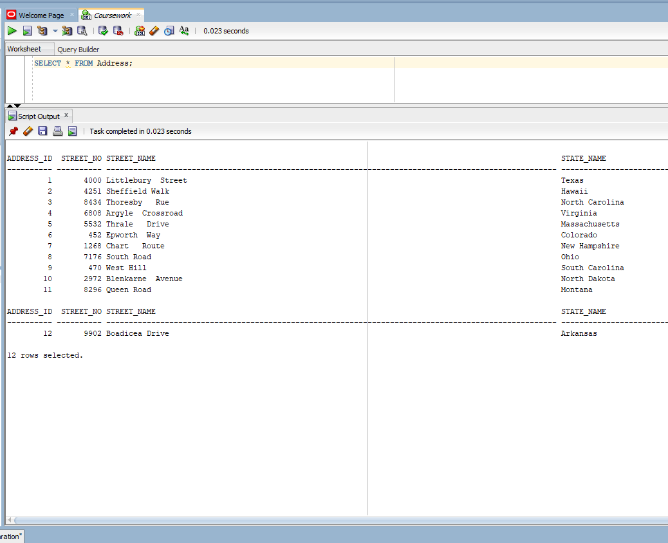

Figure :Select Address

## Address_Teacher

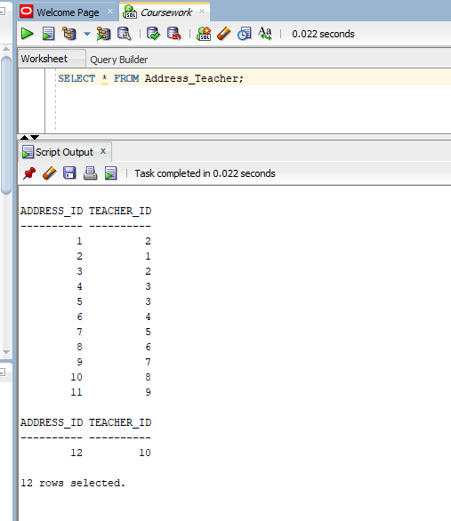

Figure :Select Address_Teacher

## Assignment

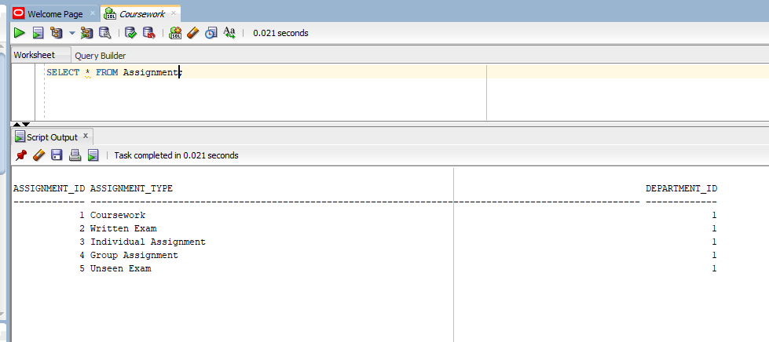

Figure :Select Assignment

## Grade

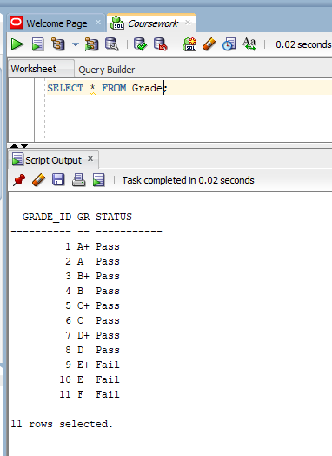

Figure :Select Grade

## Module

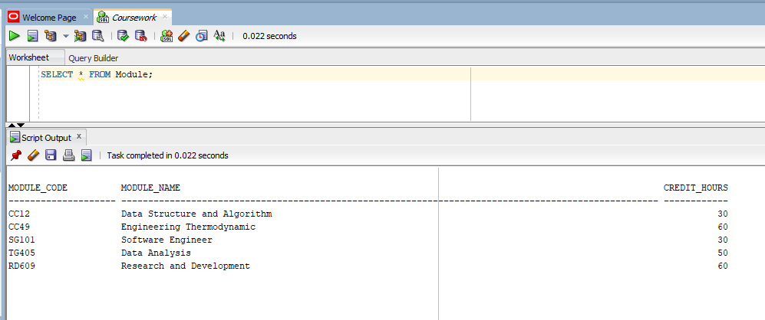

Figure :Select Module

## Module_Student

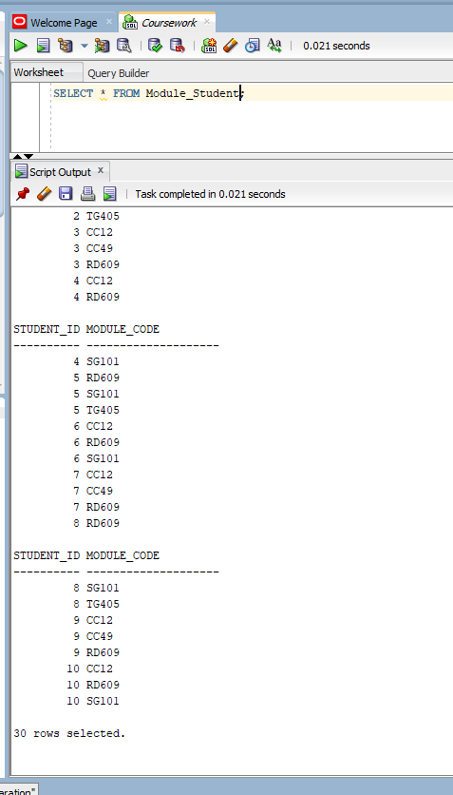

Figure :Select Module_Student

## Module_Teacher

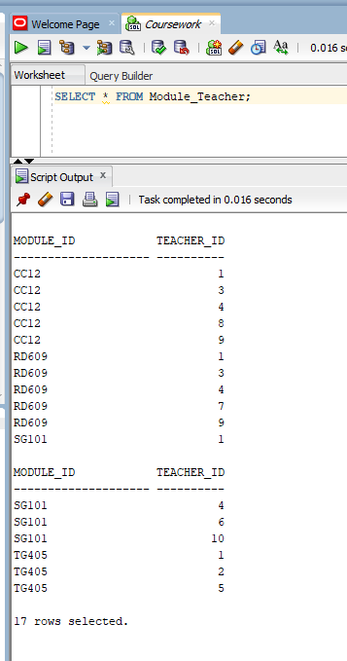

Figure :Select Module_Teacher

## Semester

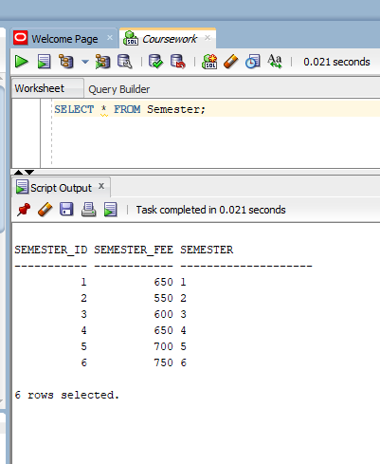

Figure :Select Semester

## Student

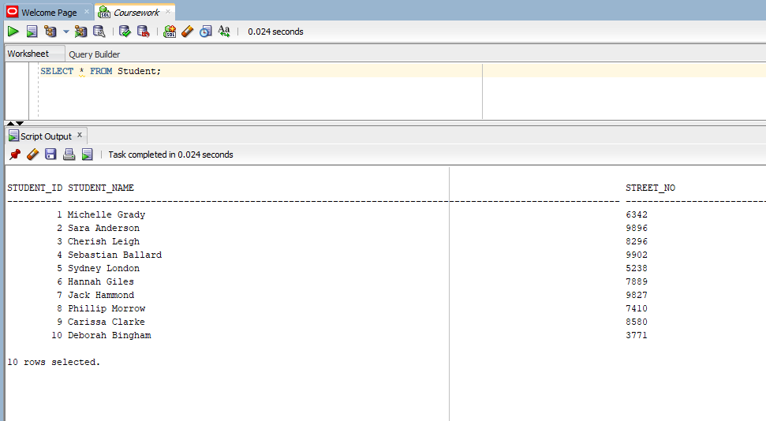

Figure :Select Student

## Student_Assignment

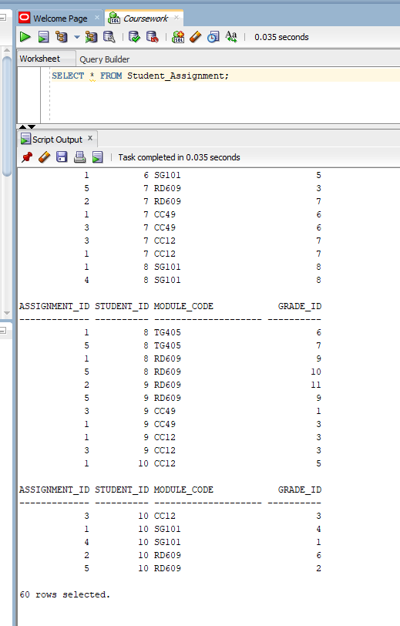

Figure :Select Student_Assignment

## Student_Attendance

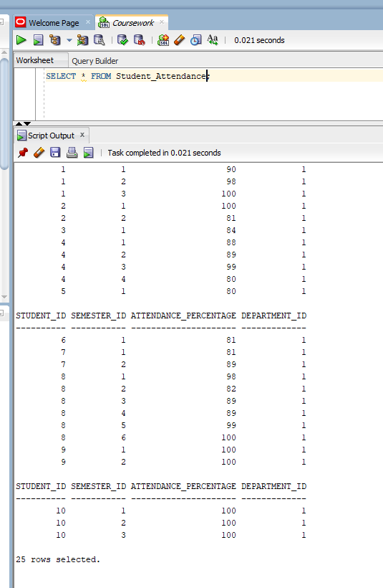

Figure :Select Attendance

## Student_Fees

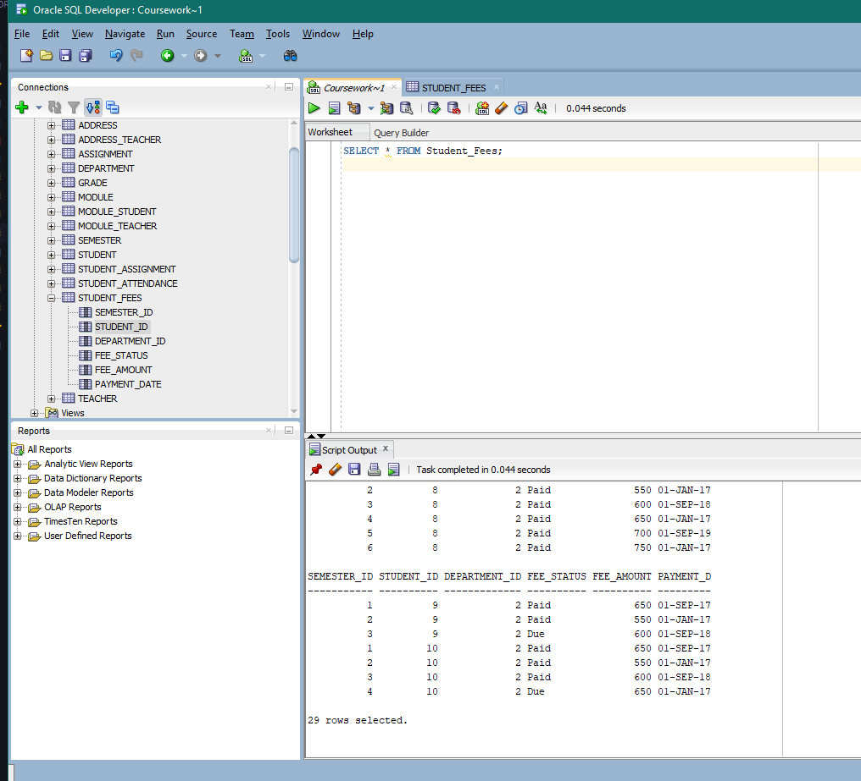

Figure :Select Fees

## Teacher

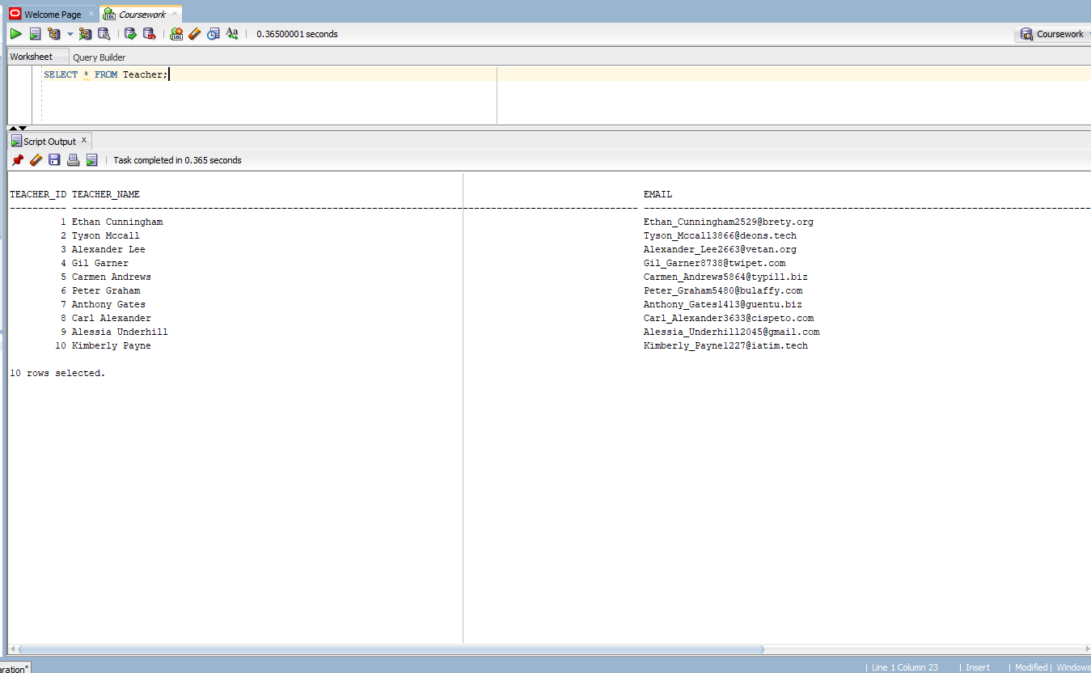

Figure :Select Teacher

# Forms

## Dashboard

Figure : WebForms Dashboard

## Basic Forms

### Teacher Form

Figure : Teacher Form

### Address Form

Figure : Teacher Form

### Module Form

Figure : Module Form

### Department Form

Figure : Department Form

### Student Form

Figure : Student Form

## Complex Forms

### Teacher-Module Mapping

#### Form

Figure : Teacher Module Mapping Form Before Selection

Figure : Teacher Module Mapping Form After Selection

#### Query

Assuming the selected student has student_id 1, the query is as following:

1. SELECT m.Module_Code as "Module Code", mt.Teacher_ID "Teacher ID", m.Module_Name as "Module Name", m.Credit_Hours "Credit Hours"
2. FROM Module m
3. INNER JOIN Module_Teacher mt ON mt.Module_ID = m.Module_Code
4. WHERE mt.Teacher_ID = 1
5. ;

In the webform the query string is written as:

1. $@"SELECT m.Module_Code as ""Module Code"", mt.Teacher_ID ""Teacher ID"", m.Module_Name as ""Module Name"", m.Credit_Hours ""Credit Hours""
2. FROM Module m
3. INNER JOIN Module_Teacher mt ON mt.Module_ID = m.Module_Code
4. WHERE mt.Teacher_ID = {teacherID}
5. ";

## Student-Fees Mapping

#### Form

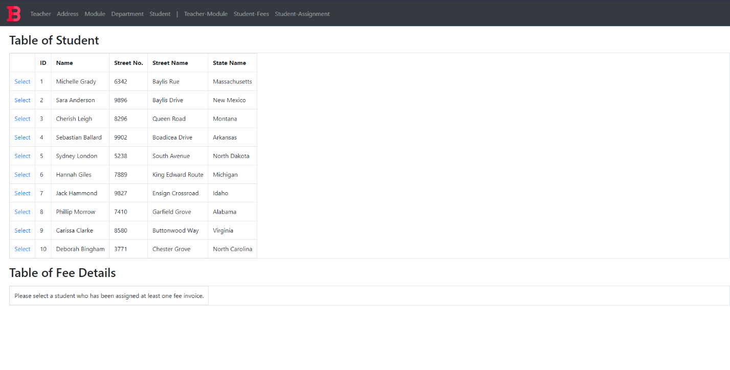

Figure : Student-Fees Mapping Form Before Selection

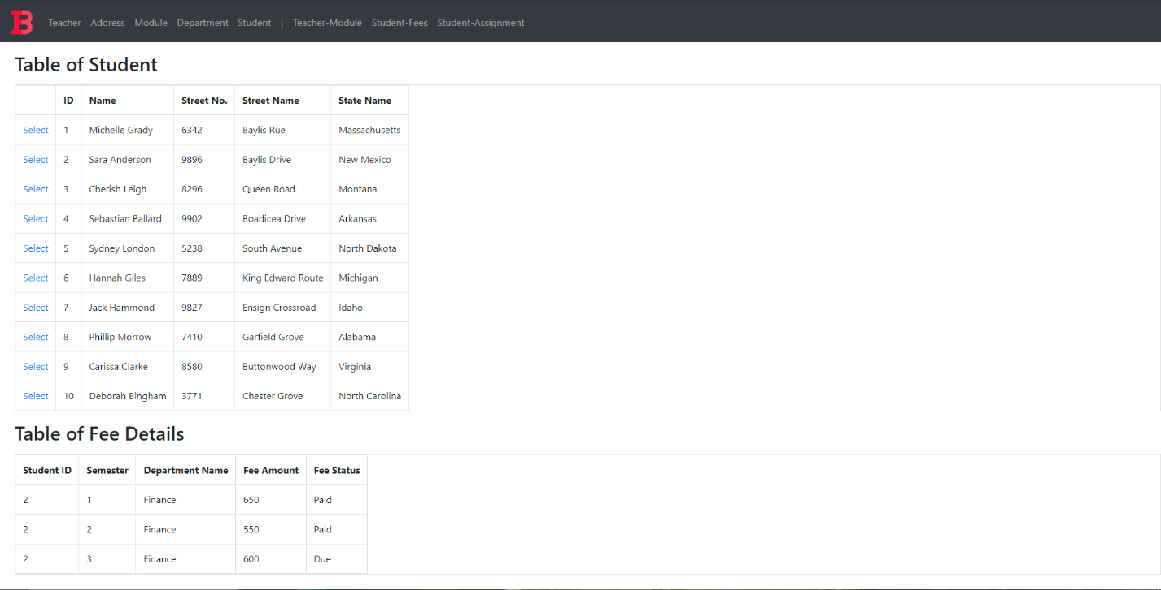 Figure : Student-Fees Mapping Form After Selection

#### Query

Assuming the selected student has student_id 1, the query is as following:

1. SELECT sf.Student_ID "Student ID", se.Semester "Semester", d.Department_Name as "Department Name", sf.Fee_Amount "Fee Amount", sf.Fee_Status "Fee Status"
2. FROM Student s
3. INNER JOIN Student_Fees sf ON sf.Student_ID = s.Student_ID
4. INNER JOIN Semester se ON se.Semester_ID = sf.Semester_ID
5. INNER JOIN Department d ON d.Department_ID = sf.Department_ID
6. WHERE sf.Student_ID = 1
7. ;

In the webform the query string is written as:

1. $@"SELECT sf.Student_ID ""Student ID"", se.Semester ""Semester"", d.Department_Name as ""Department Name"", sf.Fee_Amount ""Fee Amount"", sf.Fee_Status ""Fee Status""
2. FROM Student s
3. INNER JOIN Student_Fees sf ON sf.Student_ID = s.Student_ID
4. INNER JOIN Semester se ON se.Semester_ID = sf.Semester_ID
5. INNER JOIN Department d ON d.Department_ID = sf.Department_ID
6. WHERE sf.Student_ID = {studentID}
7. ";

## Student-Assignment Mapping

#### Form

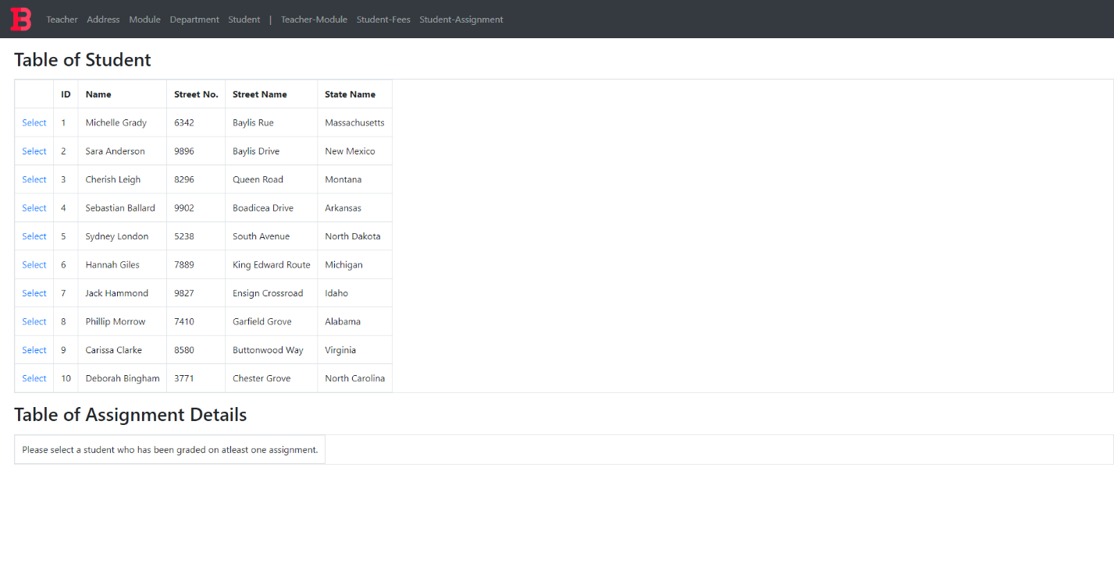

Figure : Student-Assignment Mapping Form Before Selection

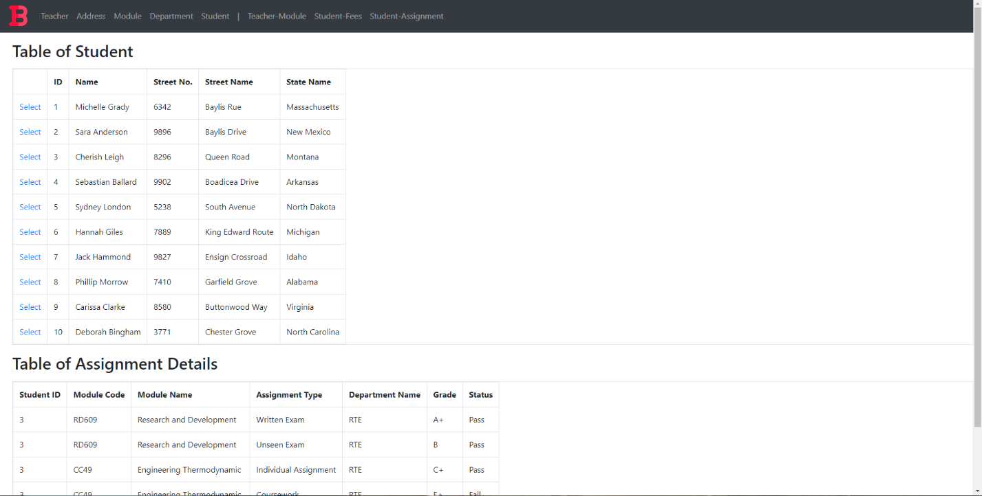 Figure : Student-Fees Mapping Form After Selection

#### Query

Assuming the selected student has student_id 1, the query is as following:

1. SELECT sa.Student_ID "Student ID", m.Module_Code "Module Code" , m.Module_Name "Module Name", a.Assignment_Type "Assignment Type" , d.Department_Name "Department Name" , g.Grade "Grade", g.Status "Status"
2. FROM Student s
3. INNER JOIN Student_Assignment sa ON sa.Student_ID = s.Student_ID
4. INNER JOIN Grade g ON sa.Grade_ID = g.Grade_ID
5. INNER JOIN Module m ON sa.Module_Code = m.Module_Code
6. INNER JOIN Assignment a ON sa.Assignment_ID = a.Assignment_ID
7. INNER JOIN Department d ON a.Department_ID = d.Department_ID
8. WHERE sa.Student_ID = 1;

In the webform the query string is written as:

1. $@"SELECT sa.Student_ID ""Student ID"", m.Module_Code ""Module Code"" , m.Module_Name ""Module Name"", a.Assignment_Type ""Assignment Type"" ,
2. d.Department_Name ""Department Name"" , g.Grade ""Grade"", g.Status ""Status""
3. FROM Student s
4. INNER JOIN Student_Assignment sa ON sa.Student_ID = s.Student_ID
5. INNER JOIN Grade g ON sa.Grade_ID = g.Grade_ID
6. INNER JOIN Module m ON sa.Module_Code = m.Module_Code
7. INNER JOIN Assignment a ON sa.Assignment_ID = a.Assignment_ID
8. INNER JOIN Department d ON a.Department_ID = d.Department_ID
9. WHERE sa.Student_ID = {studentID}
10. ";

# User Manual

If the project is run without changing the port settings, then the url for the project is:

**https://localhost:44370/Index.aspx**

## Included Content

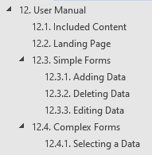

## Landing Page

Figure : Landing Page

Shown above is the landing page of the project.

It contains a navigation bar description the webforms.

The user can always click on the logo at the top left to get back to the dashboard or continue navigating through the provided navigation bar.

Figure : Form Types on Landing Page

Form types are shown on the top of each description for ease of access.

## Simple Forms

Figure : Simple Form

Shown above is the simple form for modules

### Adding Data

Figure Simple Form Add button

After filling out the required fields, simply press the Add button to add the entered data.

The data will be added to the form immediately as shown in the image below.

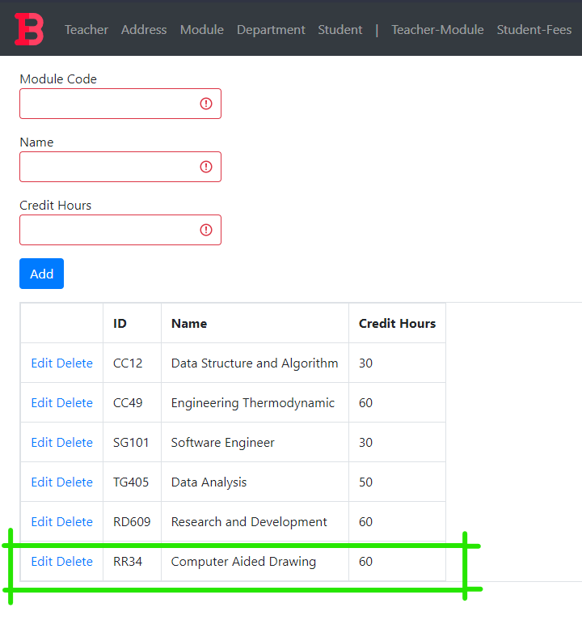

Figure : Data Added

### Deleting Data

To delete data, simply click the delete button next to the data you want to delete.

Figure : Delete Button

A confirmation prompt appears, and after clicking the OK button, the data gets deleted.

Figure : Deletion confirmation

Figure : Post Deletion Form

The data got removed as shown above.

### Editing Data

To edit or update data, simply click on Edit.

Figure : Edit button

After clicking the edit button, the Add button disappears and an update button appears as shown below.

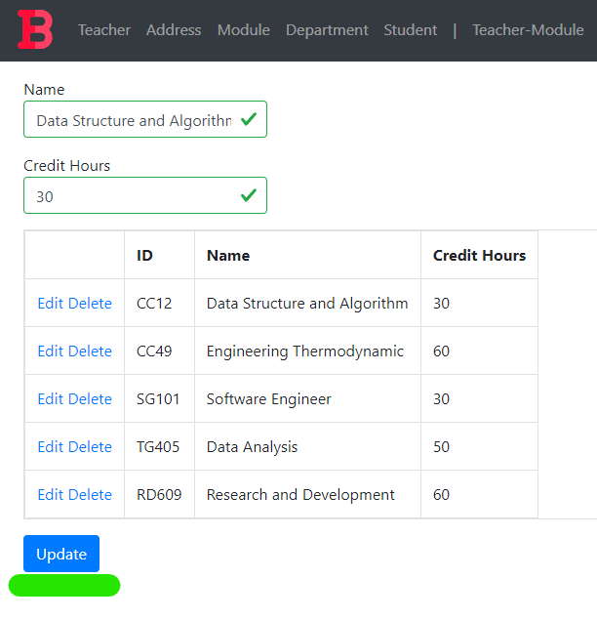

Figure : Update Button

Make any changes you may want to and press the update button

Here, the credit hours has been changed to 60 in place of 30.

As shown in the image above, the credit hour of Data Structure and Algorithm has been updated to 60, and the add button reappears.

## Complex Forms

Figure : Complex Form

Shown above is a complex form for teacher-module mapping.

### Selecting a Data

In order to view the mapping, a data row must be selected in the displayed grid.

Figure : Select Button

To select a data row, simply click on its corresponding select button as shown in the figure above.

Figure : Complex form Post Selection

In this complex form example, a teacher was selected and the details of the module they teach were displayed in another grid below.

# Testing

## Basic Forms

### Teacher Form

#### Test 1: View

|  |  |  |
| --- | --- | --- |
| **Test Condition** | **Expected Outcome** | **Obtained Outcome** |
| Load the teacher form and check if data is loaded in the grid. | The data is loaded on page load. | The data was loaded on page load. |

Table : Teacher Test 1

Figure : Teacher Test 1 evidence

#### Test 2: Add

|  |  |  |
| --- | --- | --- |
| **Test Condition** | **Expected Outcome** | **Obtained Outcome** |
| Fill the teacher form appropriately and press the add button. | The data is added, and the grid is refreshed with the new data. | The data was added without any errors and the grid was refreshed with the new data. |

Table : Teacher Test 2

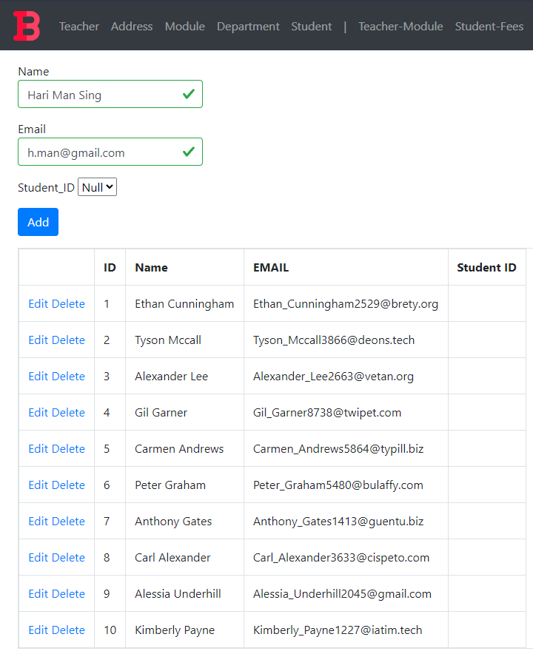

Figure : Teacher Test 2 Added Data

Figure : Teacher Test 2 Addition Result

#### Test 3: Edit

|  |  |  |
| --- | --- | --- |
| **Test Condition** | **Expected Outcome** | **Obtained Outcome** |
| Click the edit button | * The add button disappears and an update button appears. * The data in the row gets filled in the available textboxes. | * The add button disappeared and an update button appeared. * The data in the field got filled in the available textboxes. |
| Click the update button | * The update button disappears and the add button reappears * The data in the grid is refreshed with the edited data. | * The update button disappears and the add button reappears * The data in the grid is refreshed with the edited data. |

Table : Teacher Test 3

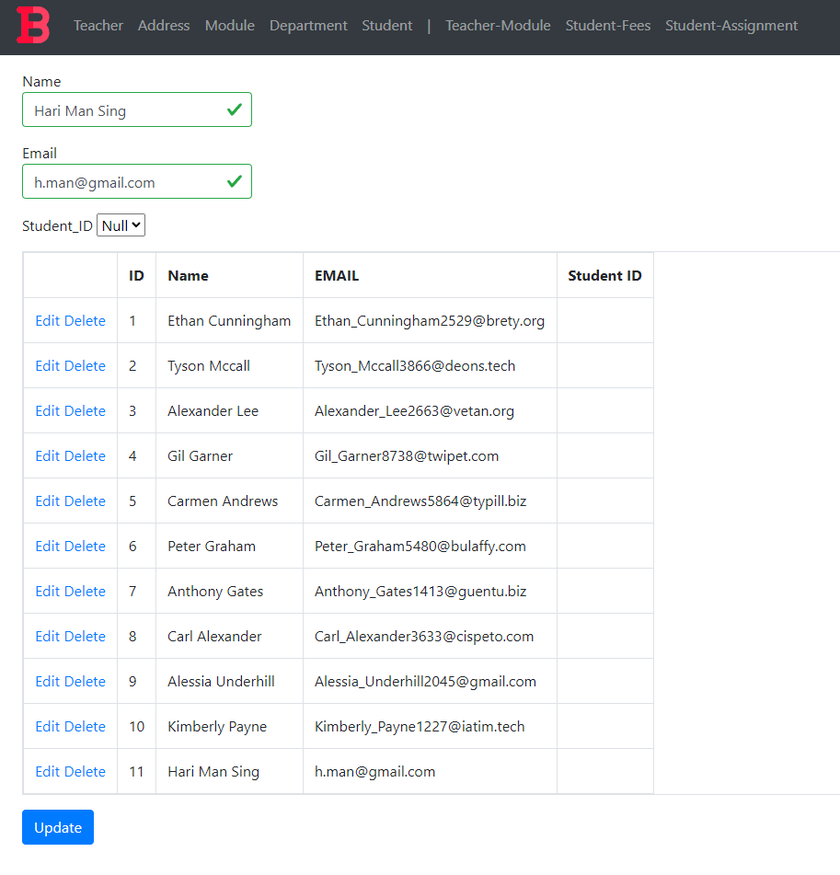

Figure : Teacher Test 3 condition 1

Figure : Edited value in Email Textbox

Figure : Teacher Test 3 Condition 2

#### Test 4: Delete

|  |  |  |
| --- | --- | --- |
| **Test Condition** | **Expected Outcome** | **Obtained Outcome** |
| Click the delete button. | The grid is refreshed with the data row deleted. | The grid was refreshed with the data row deleted. |

Table : Teacher Test 4

Figure : Teacher Grid Pre-Deletion

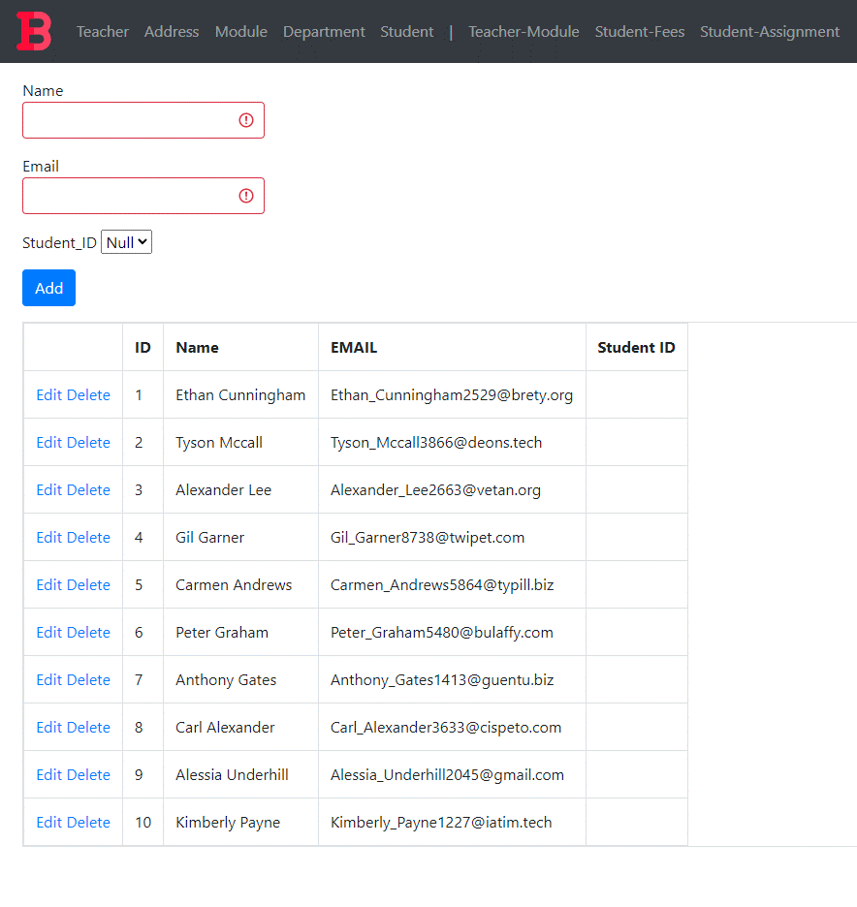

Figure : Teacher Grid Post-Deletion

### Address Form

#### Test 1: View

|  |  |  |
| --- | --- | --- |
| **Test Condition** | **Expected Outcome** | **Obtained Outcome** |
| Load the address form and check if data is loaded in the grid. | The data is loaded on page load. | The data was loaded on page load. |

Table : Address Test 1

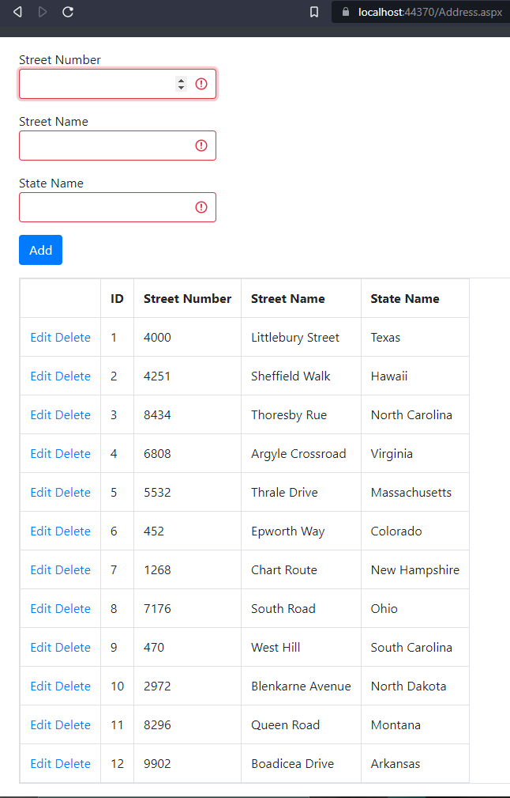

Figure : Address Test 1 evidence

#### Test 2: Add

|  |  |  |
| --- | --- | --- |
| **Test Condition** | **Expected Outcome** | **Obtained Outcome** |
| Fill the address form appropriately and press the add button. | The data is added, and the grid is refreshed with the new data. | The data was added without any errors and the grid was refreshed with the new data. |

Table : Address Test 2

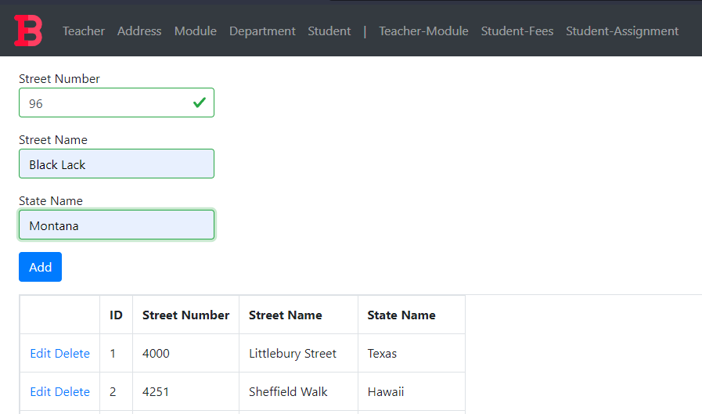

Figure : Address Test 2 Data to be Added

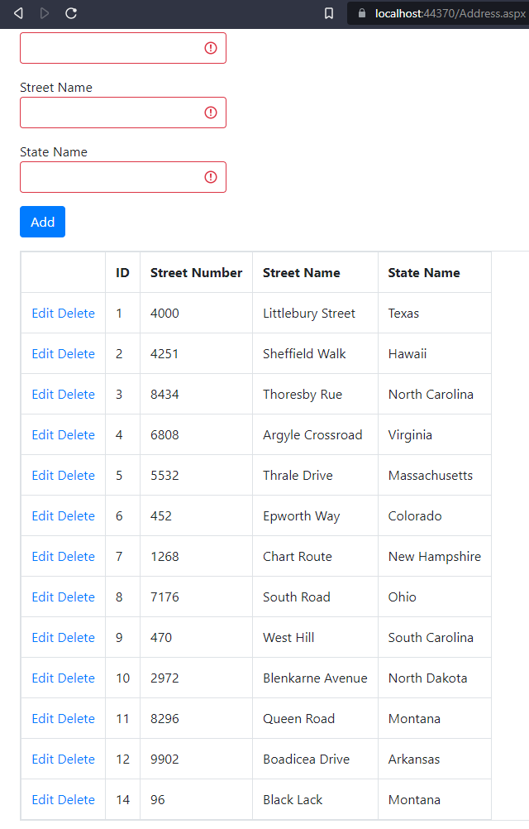

Figure : Address Test 2 Addition Result

#### Test 3: Edit

|  |  |  |
| --- | --- | --- |
| **Test Condition** | **Expected Outcome** | **Obtained Outcome** |
| Click the edit button | * The add button disappears and an update button appears. * The data in the row gets filled in the available textboxes. | * The add button disappeared and an update button appeared. * The data in the field got filled in the available textboxes. However, the street number got loaded into all textboxes |

Table : Address Test 3 Fail Case

Figure : Address Test 3 condition 1 fail case

##### What caused the issue and how it was rectified:

Figure : Issue causing the fail case

The textboxes were updated with the grid row cell containing the street number value.

Once they were changed, relevant values got added to the respective textboxes.

Figure : Rectification of the Issue causing the fail case

Figure : Test 3 Condition 1 post rectification

|  |  |  |
| --- | --- | --- |
| **Test Condition** | **Expected Outcome** | **Obtained Outcome** |
| Click the update button | * The update button disappears and the add button reappears * The data in the grid is refreshed with the edited data. | * The update button disappears and the add button reappears * The data in the grid is refreshed with the edited data. |

Table : Address Test 3 condition 2

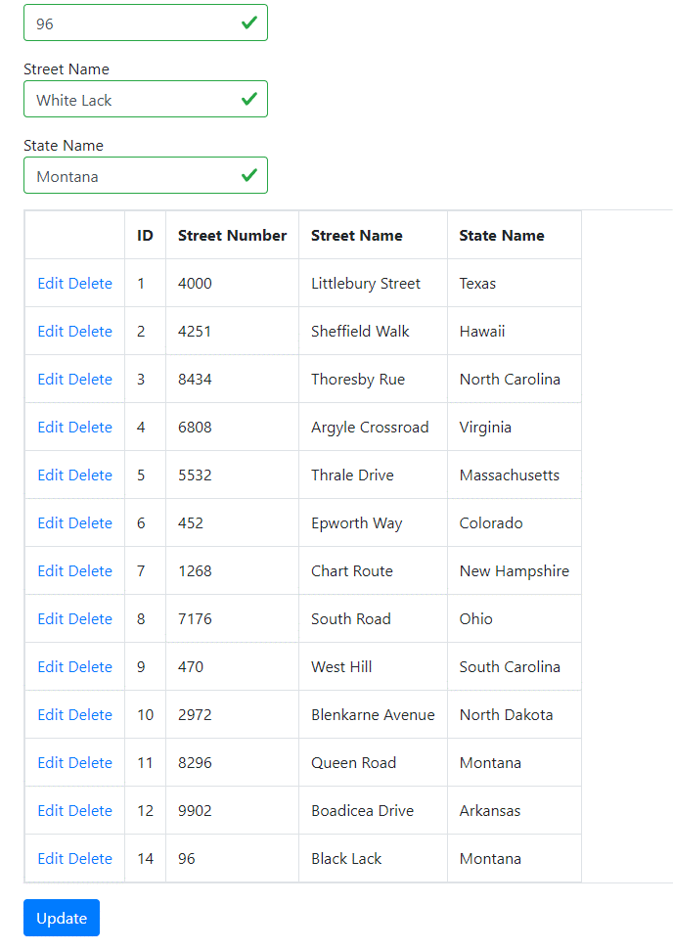

Figure : Edited value in Street Name Textbox

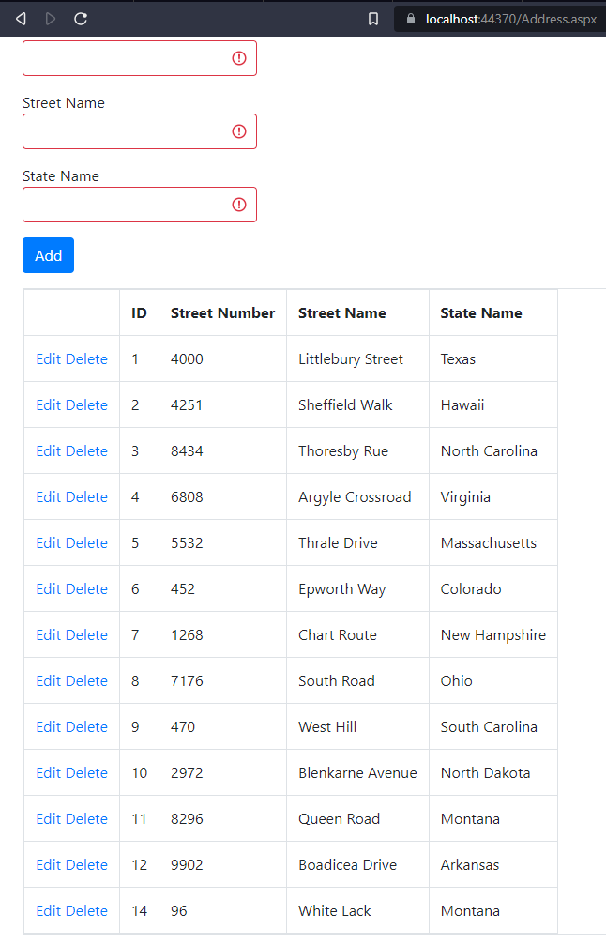

Figure : Address Test 3 Condition 2

#### Test 4: Delete

|  |  |  |
| --- | --- | --- |
| **Test Condition** | **Expected Outcome** | **Obtained Outcome** |
| Click the delete button. | The grid is refreshed with the data row deleted. | The grid was refreshed with the data row deleted. |

Table : Address Test 4

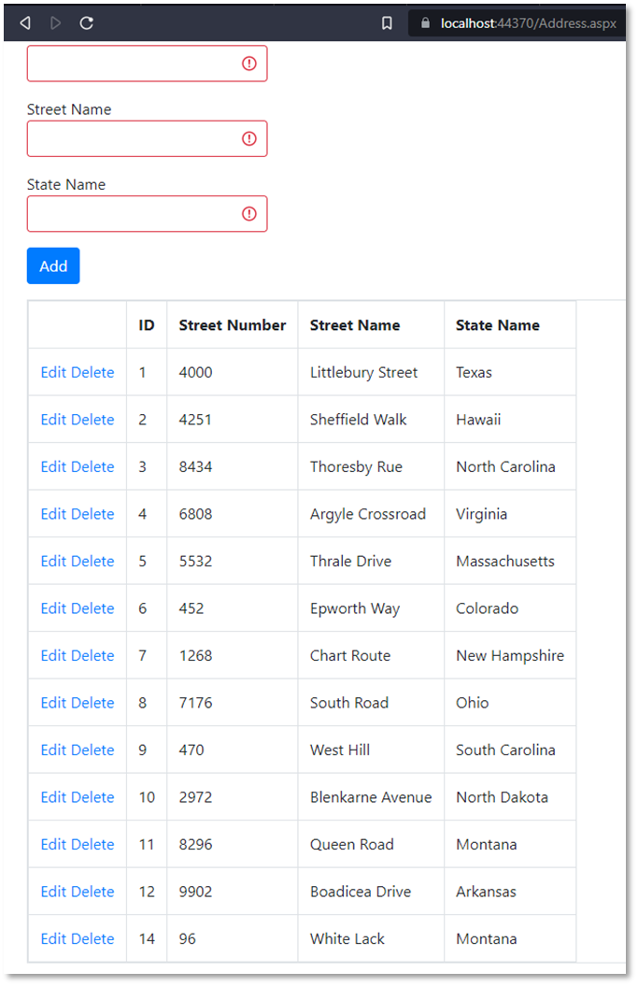

Figure : Address Grid Pre-Deletion

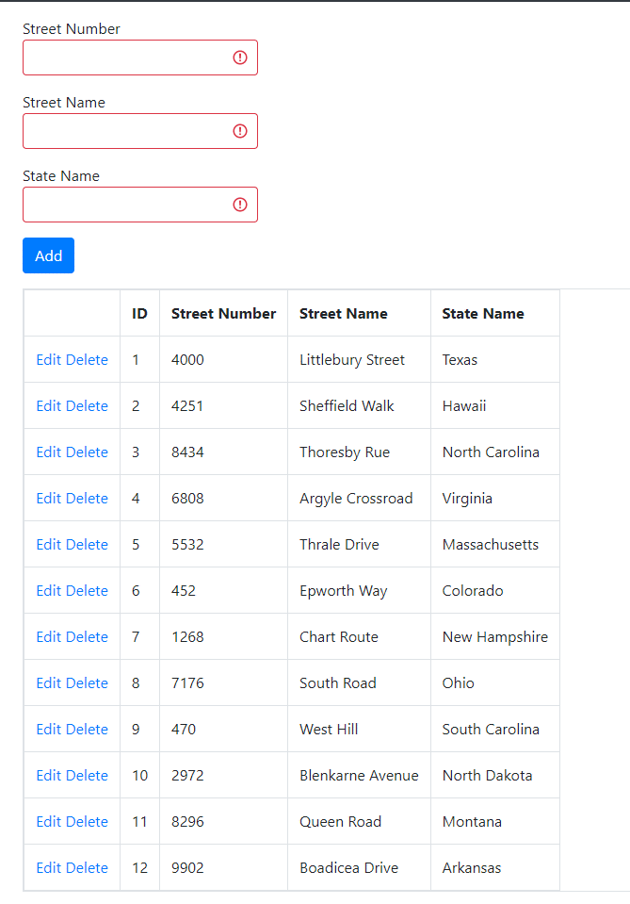

Figure : Address Grid Post-Deletion

### Module Form

#### Test 1: View

|  |  |  |
| --- | --- | --- |
| **Test Condition** | **Expected Outcome** | **Obtained Outcome** |
| Load the module form and check if data is loaded in the grid. | The data is loaded on page load. | The data was loaded on page load. |

Table : Module Test 1

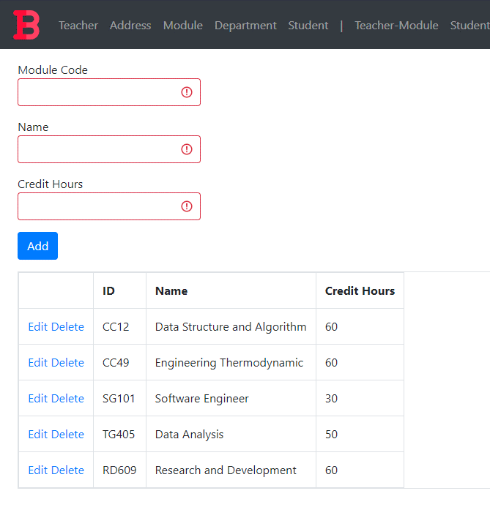

Figure : Module Test 1 evidence

#### Test 2: Add

|  |  |  |
| --- | --- | --- |
| **Test Condition** | **Expected Outcome** | **Obtained Outcome** |
| Fill the module form appropriately and press the add button. | The data is added, and the grid is refreshed with the new data. | The data was added without any errors and the grid was refreshed with the new data. |

Table : Module Test 2

Figure : Module Test 2 Data to be Added

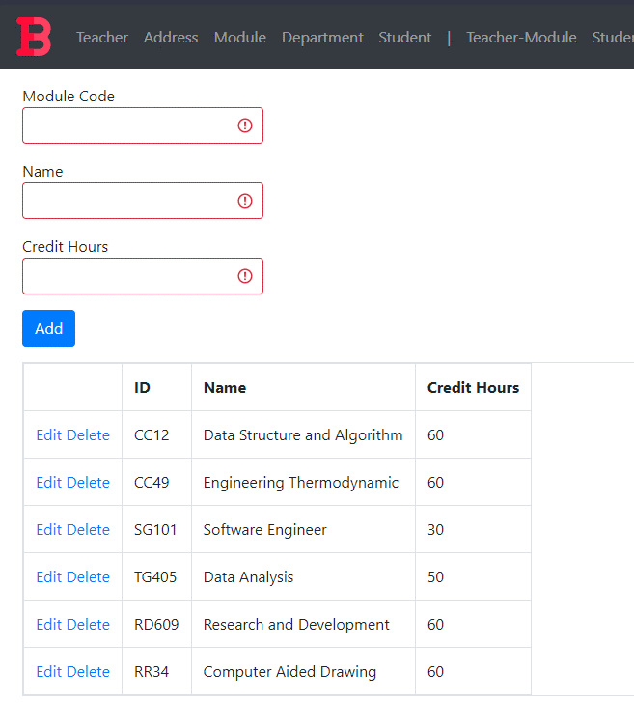

Figure : Module Test 2 Addition Result

#### Test 3: Edit

|  |  |  |
| --- | --- | --- |
| **Test Condition** | **Expected Outcome** | **Obtained Outcome** |
| Click the edit button | * The add button disappears and an update button appears. * The data in the row gets filled in the available textboxes. | * The add button disappeared and an update button appeared. * The data in the field got filled in the available textboxes. |
| Click the update button | * The update button disappears and the add button reappears * The data in the grid is refreshed with the edited data. | * The update button disappears and the add button reappears * The data in the grid is refreshed with the edited data. |

Table : Module Test 3

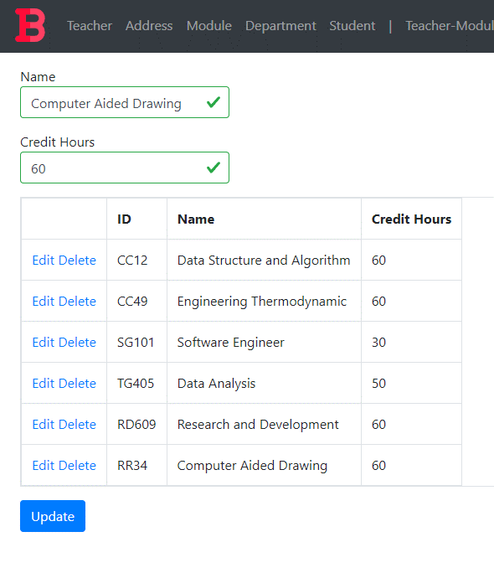

Figure : Module Test 3 condition 1

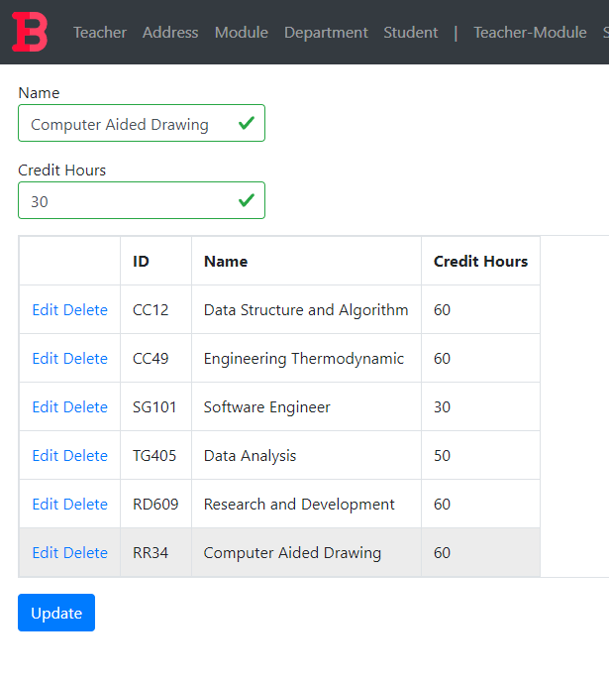

Figure : Edited value in Credit Hours Textbox

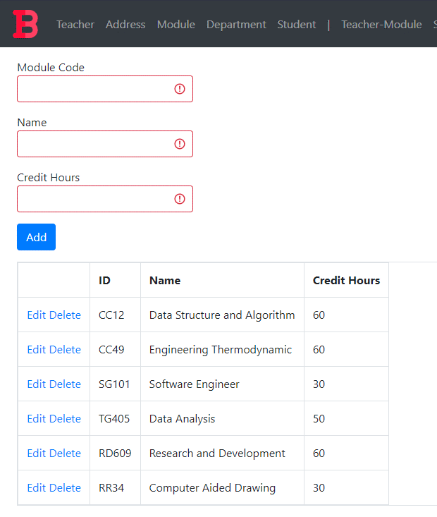

Figure : Module Test 3 Condition 2

#### Test 4: Delete

|  |  |  |
| --- | --- | --- |
| **Test Condition** | **Expected Outcome** | **Obtained Outcome** |
| Click the delete button. | The grid is refreshed with the data row deleted. | The grid was refreshed with the data row deleted. |

Table : Module Test 4



Figure : Address Grid Pre-Deletion

##### What caused the issue and how it was rectified:

Figure : Issue causing the fail case

Unlike the primary keys from other form table, module table had a VARCHAR primary key. Here, I was trying to convert the string into an integer in order to obtain the primary key for the row of data that needed to be deleted. Hence, it caused a format exception and did not carry out the delete procedure.

I set the variable to string and used the value obtained from the grid view row as a string and rectified the issue. This made the deletion procedure go smoothly and uninterrupted.

Figure : Rectification of the Issue causing the fail case

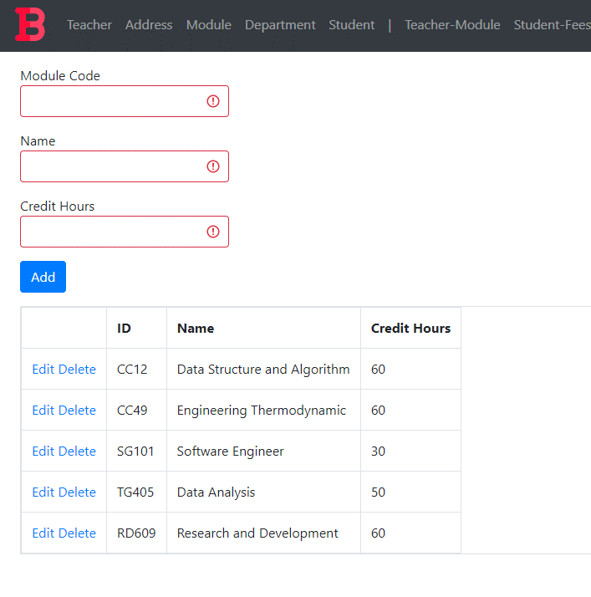

Figure : Test 4 post deletion

### Department Form

#### Test 1: View

|  |  |  |
| --- | --- | --- |
| **Test Condition** | **Expected Outcome** | **Obtained Outcome** |
| Load the department form and check if data is loaded in the grid. | The data is loaded on page load. | The data was loaded on page load. |

Table : Department Test 1

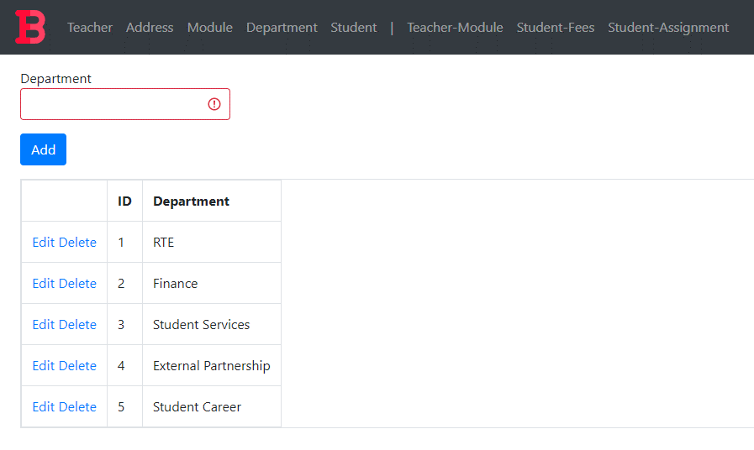

Figure : Department Test 1 evidence

#### Test 2: Add

|  |  |  |
| --- | --- | --- |
| **Test Condition** | **Expected Outcome** | **Obtained Outcome** |
| Fill the department form appropriately and press the add button. | The data is added, and the grid is refreshed with the new data. | The data was added without any errors and the grid was refreshed with the new data. |

Table : Department Test 2

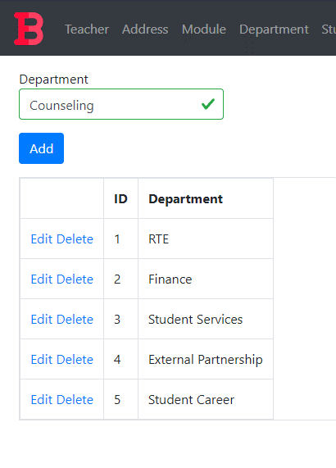

Figure : Department Test 2 Added Data

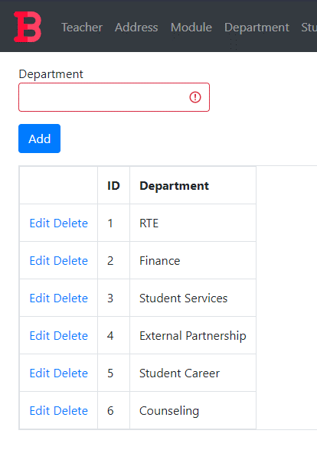

Figure : Department Test 2 Addition Result

#### Test 3: Edit

|  |  |  |
| --- | --- | --- |
| **Test Condition** | **Expected Outcome** | **Obtained Outcome** |
| Click the edit button | * The add button disappears and an update button appears. * The data in the row gets filled in the available textboxes. | * The add button disappeared and an update button appeared. * The data in the field got filled in the available textboxes. |
| Click the update button | * The update button disappears and the add button reappears * The data in the grid is refreshed with the edited data. | * The update button disappears and the add button reappears * The data in the grid is refreshed with the edited data. |

Table : Department Test 3

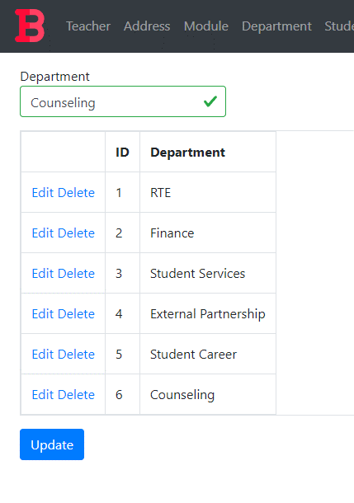

Figure : Department Test 3 condition 1

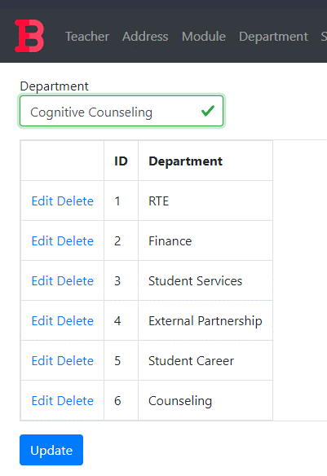

Figure : Edited value in Department Textbox

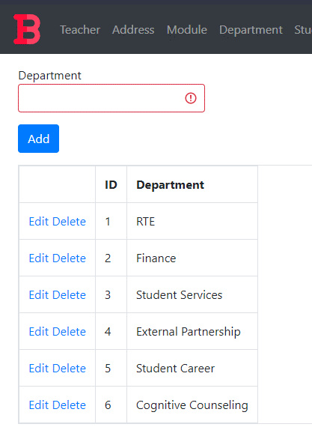

Figure : Department Test 3 Condition 2

#### Test 4: Delete

|  |  |  |
| --- | --- | --- |
| **Test Condition** | **Expected Outcome** | **Obtained Outcome** |
| Click the delete button. | The grid is refreshed with the data row deleted. | The grid was refreshed with the data row deleted. |

Table : Department Test 4



Figure : Department Grid Pre-Deletion

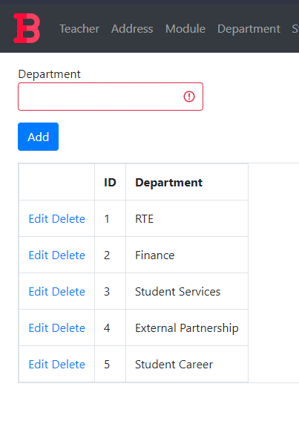

Figure : Department Grid Post-Deletion

### Student Form

#### Test 1: View

|  |  |  |
| --- | --- | --- |
| **Test Condition** | **Expected Outcome** | **Obtained Outcome** |
| Load the student form and check if data is loaded in the grid. | The data is loaded on page load. | The data was loaded on page load. |

Table : Student Test 1

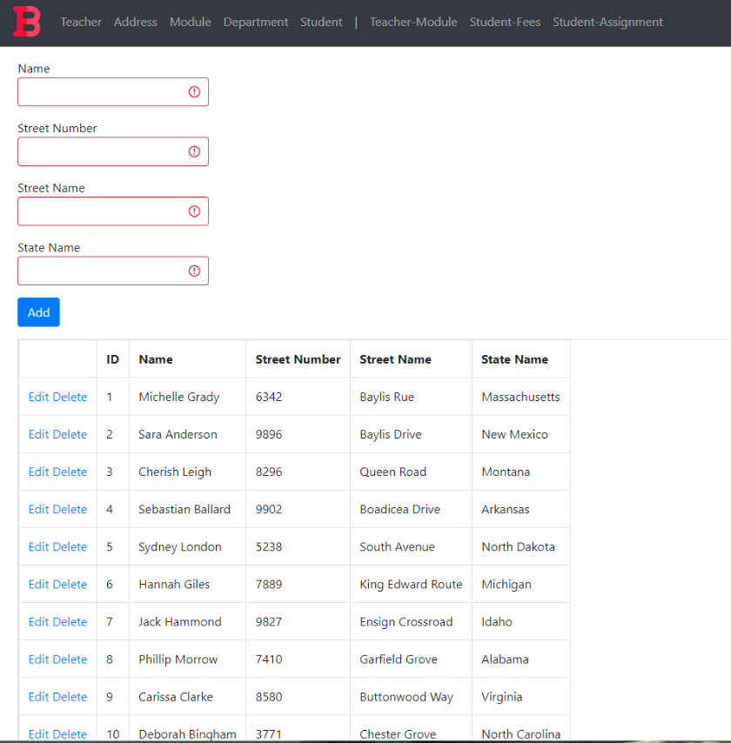

Figure : Student Test 1 evidence

#### Test 2: Add

|  |  |  |
| --- | --- | --- |
| **Test Condition** | **Expected Outcome** | **Obtained Outcome** |
| Fill the student form appropriately and press the add button. | The data is added, and the grid is refreshed with the new data. | The data was added without any errors and the grid was refreshed with the new data. |

Table : Student Test 2

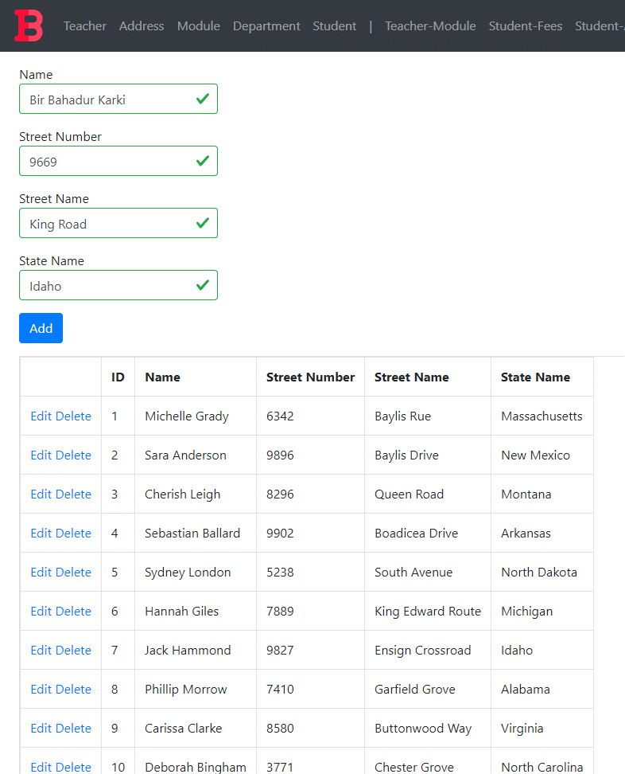

Figure : Student Test 2 Added Data

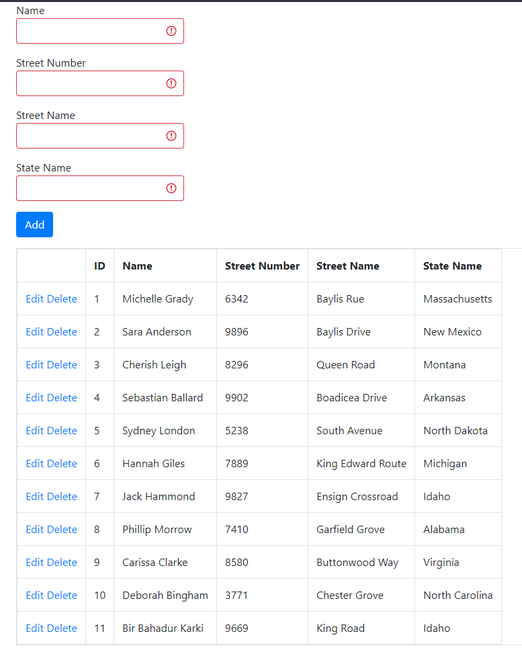

Figure : Student Test 2 Addition Result

#### Test 3: Edit

|  |  |  |
| --- | --- | --- |
| **Test Condition** | **Expected Outcome** | **Obtained Outcome** |
| Click the edit button | * The add button disappears and an update button appears. * The data in the row gets filled in the available textboxes. | * The add button disappeared and an update button appeared. * The data in the field got filled in the available textboxes. |
| Click the update button | * The update button disappears and the add button reappears * The data in the grid is refreshed with the edited data. | * The update button disappears and the add button reappears * The data in the grid is refreshed with the edited data. |

Table : Student Test 3

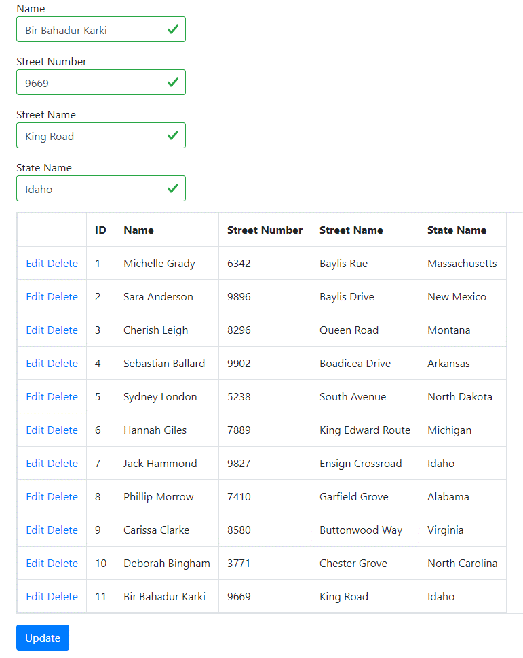

Figure : Student Test 3 condition 1

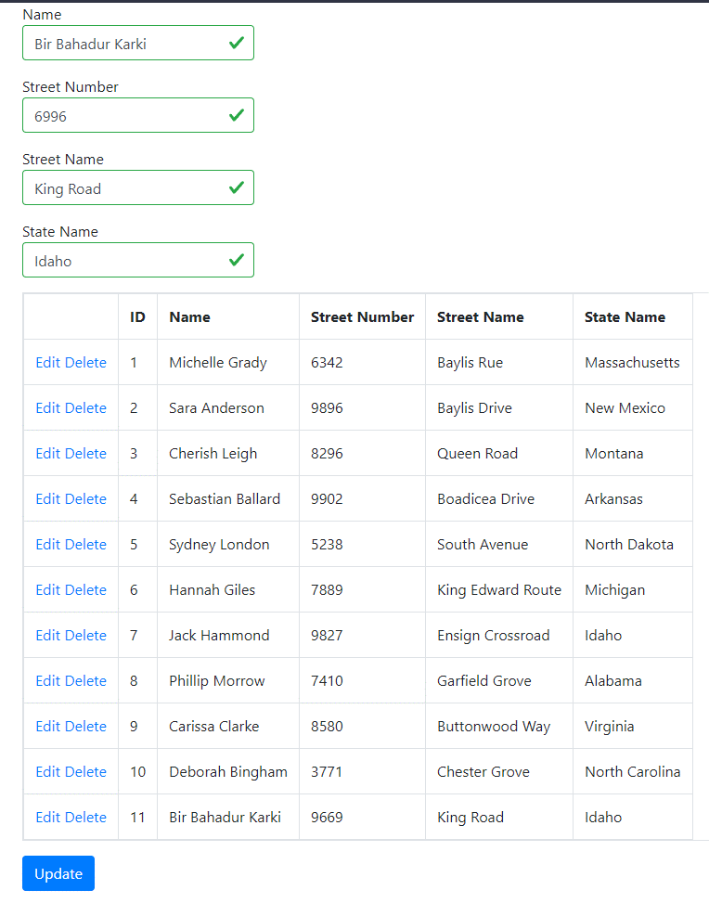

Figure : Edited value in Street Number Textbox

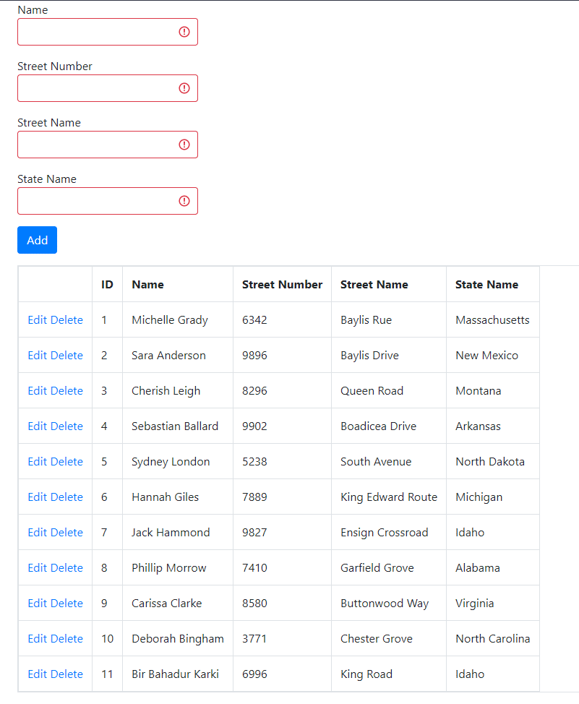

Figure : Student Test 3 Condition 2

#### Test 4: Delete

|  |  |  |
| --- | --- | --- |
| **Test Condition** | **Expected Outcome** | **Obtained Outcome** |
| Click the delete button. | The grid is refreshed with the data row deleted. | The grid was refreshed with the data row deleted. |

Table : Student Test 4



Figure : Student Grid Pre-Deletion

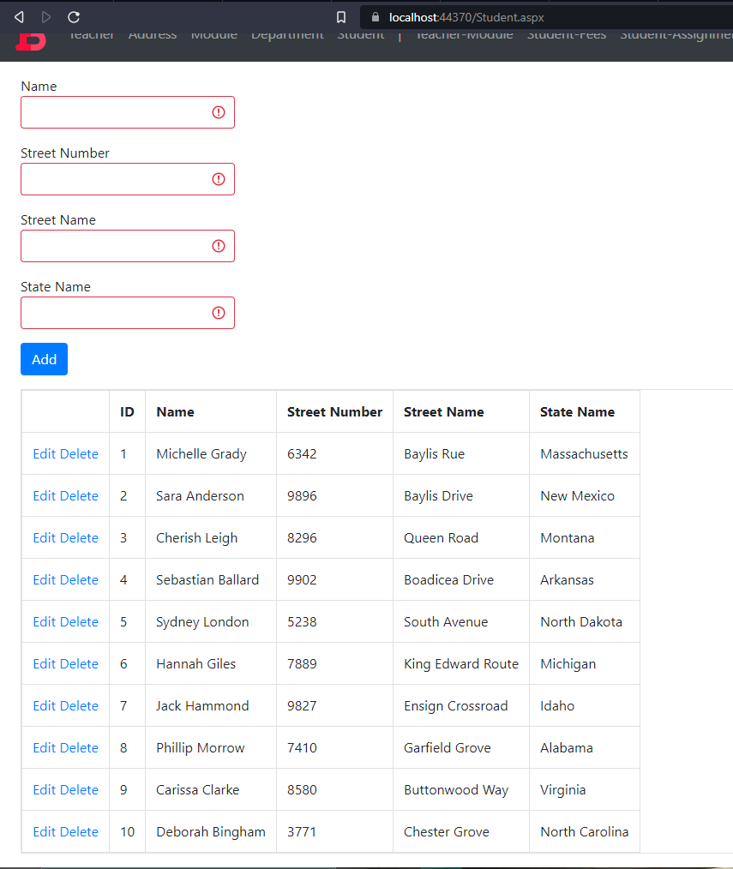

Figure : Student Grid Post-Deletion

## Complex Forms

### Teacher-Module Mapping Form

#### Test 1: Page Load

|  |  |  |
| --- | --- | --- |
| **Test Condition** | **Expected Outcome** | **Obtained Outcome** |
| Load the complex form and check if data is loaded in the initial grid. | The data is loaded to the initial grid on page load. | The data was loaded to the initial grid on page load. |

Table : Teacher-Module Test 1

Figure : Teacher-Module Test 1 evidence

#### Test 2: Data Load on Selection

|  |  |  |
| --- | --- | --- |
| **Test Condition** | **Expected Outcome** | **Obtained Outcome** |
| Select a data row from the initial grid view and check if the other grid gets loaded with relevant data. | The other grid is loaded with relevant data. | The other grid was loaded with relevant data. |

Table : Teacher-Module Test 2

Figure : Teacher-Module Test 2 evidence

### Student-Fees Mapping Form

#### Test 1: Page Load

|  |  |  |
| --- | --- | --- |
| **Test Condition** | **Expected Outcome** | **Obtained Outcome** |
| Load the complex form and check if data is loaded in the initial grid. | The data is loaded to the initial grid on page load. | The data was loaded to the initial grid on page load. |

Table : Student-Fees Test 1

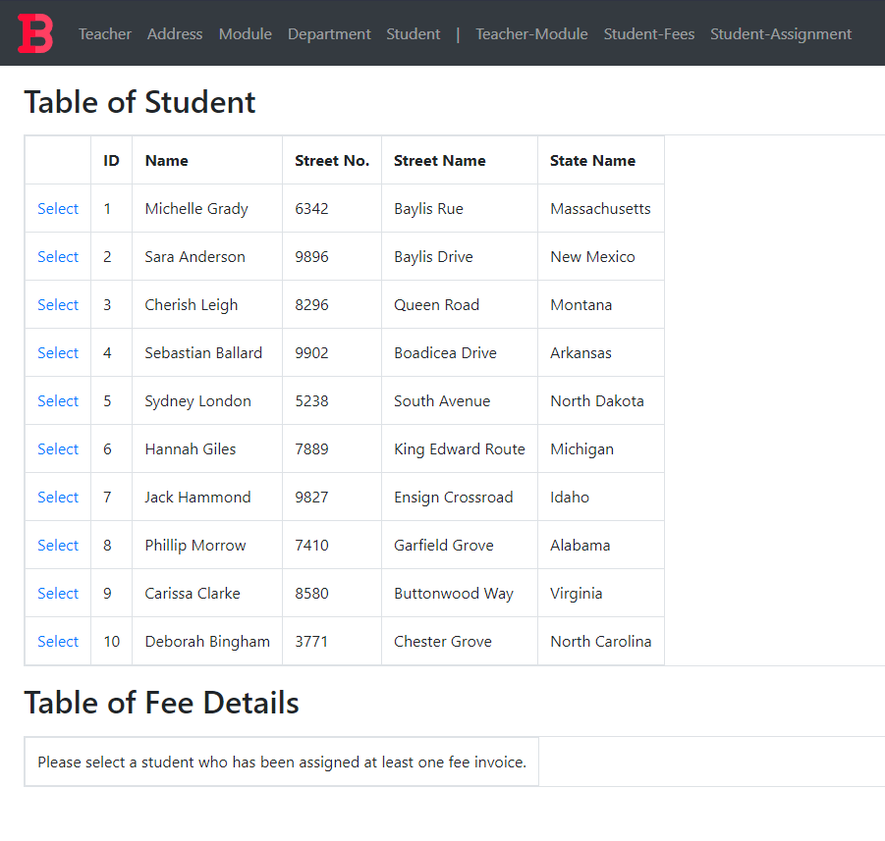

Figure : Student-Fees Test 1 evidence

#### Test 2: Data Load on Selection

|  |  |  |
| --- | --- | --- |
| **Test Condition** | **Expected Outcome** | **Obtained Outcome** |
| Select a data row from the initial grid view and check if the other grid gets loaded with relevant data. | The other grid is loaded with relevant data. | The other grid was loaded with relevant data. |

Table : Student-Fees Test 2

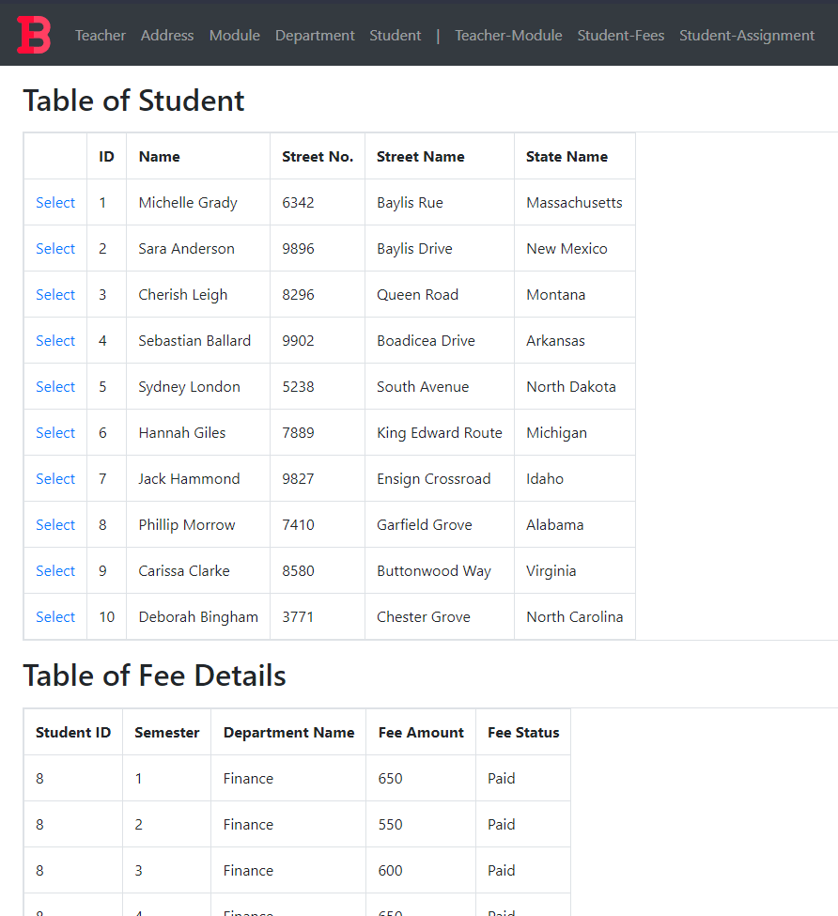

Figure : Student-Fees Test 2 evidence

### Student-Assignment Mapping Form

#### Test 1: Page Load

|  |  |  |
| --- | --- | --- |
| **Test Condition** | **Expected Outcome** | **Obtained Outcome** |
| Load the complex form and check if data is loaded in the initial grid. | The data is loaded to the initial grid on page load. | The data was loaded to the initial grid on page load. |

Table : Student-Assignment Test 1

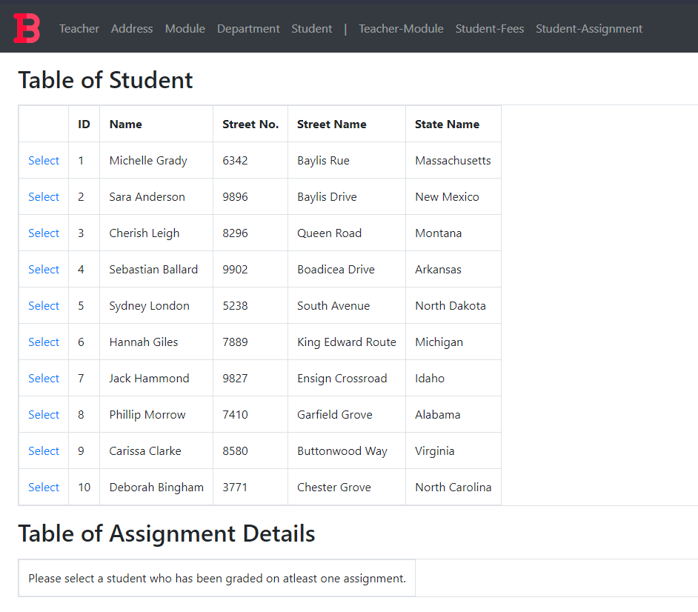

Figure : Student-Assignment Test 1 evidence

#### Test 2: Data Load on Selection

|  |  |  |
| --- | --- | --- |
| **Test Condition** | **Expected Outcome** | **Obtained Outcome** |
| Select a data row from the initial grid view and check if the other grid gets loaded with relevant data. | The other grid is loaded with relevant data. | The other grid was loaded with relevant data. |

Table : Student-Assignment Test 2

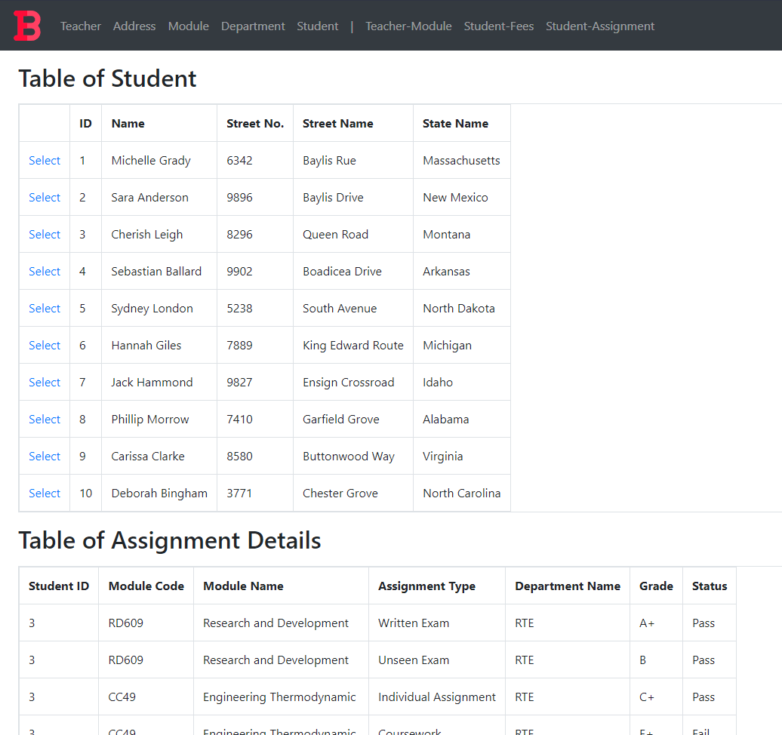

Figure : Student-Assignment Test 2 evidence

# Further Discussion

The project was a simple one, but it provided a lot of insight on oracle databases and dotnet webforms. While the database normalization, integration with assumptions, creation and data population portions were familiar to what we had already been taught, the dotnet webform creation was a unique experience in this project. As dotnet was used previously for another module to create a windows form application, I was already familiar with the dotnet syntax. Similarly, web development was also quite familiar since I had experience working with JavaScript frontend frameworks like React.

However, web development with dotnet was almost completely different than what I had experience with. The project taught me about real world business scenarios. I learned how normalization, being the useful tool that it is, sometimes does not give what we need, about how redundancy must be sometimes added artificially to keep record of things. The project also helped me better understand dotnet as a framework for web development, about how master classes can be used for page layouts, about how libraries like bootstrap can be used to visually enhance a webpage without too much effort and about HTML5 technologies such as input validation. The project also taught me about Oracle SQL sequences and triggers for auto generation of keys, about how Oracle Developer and Oracle Developer Data Modeler can be used to visualize databases, easily edit, or create tables, and generate DDL scripts. It also deepened my understanding about user permissions and Oracle database connection with third parties such as visual studio.

# Conclusion

The coursework completion fueled my feel confidence to create a database based on real world business scenario to store data in a professional manner. Since the coursework was about creating a database record system and a web application for a college, it has lots of applicability in the real world as most colleges and schools use a database to record their data. Not only schools but a lot of management systems are built the same way with different business scenarios.

All in all, the help from teachers and timely self-research turned the project from what I believe would be intimidating to a simple and fun project that taught me a ton of techniques. While the project was a simple one it taught me more about oracle, dotnet for web development and more about problem solving in general.